# 1. Installing MMRP

## 1.1 Installing Java

Please refer to <https://www.java.com/en/download/help/windows_manual_download.xml> for information on how to install Java on your system.

## 1.2 Installing MySQL

Please refer to <http://ushastry.blogspot.com/2009/06/installing-mysql-on-windows.html> for information on how to install MySQL on your system.

## 1.3 Installing MMRP

Install MMRP by downloading, or otherwise obtaining a copy of the program from Dr. Sam Thangiah. Once on the hard-drive the project needs to be imported as new project. The project was designed using JRE 7 and Eclipse Kepler. Support for other versions is limited.

## 1.4 Building The Database

This step can be skipped if you have access to the Excalibur Server at Slippery Rock University. The MMRP application will automatically attempt to use the Excalibur Server if no other database set is performed.

The building a new database option is currently not supported in this version of MMRP. The project requires access to the Excalibur Server at Slippery Rock University at this time.

# 2. About MMRP

## 2.1 Starting Up MMRP

1. From the project explorer, expand the GUI package and right click on the Main_Source.java file, pictured in Figure 1.
2. Select Run As >> Java Application.
3. You will see the screen in Figure 2. This is the main screen, from this screen

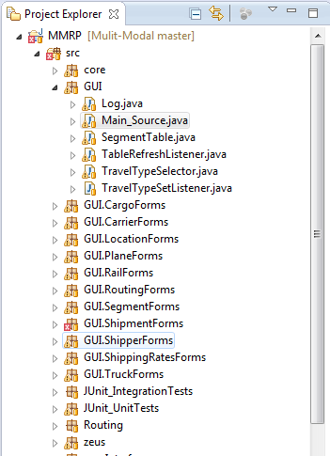

Figure 1

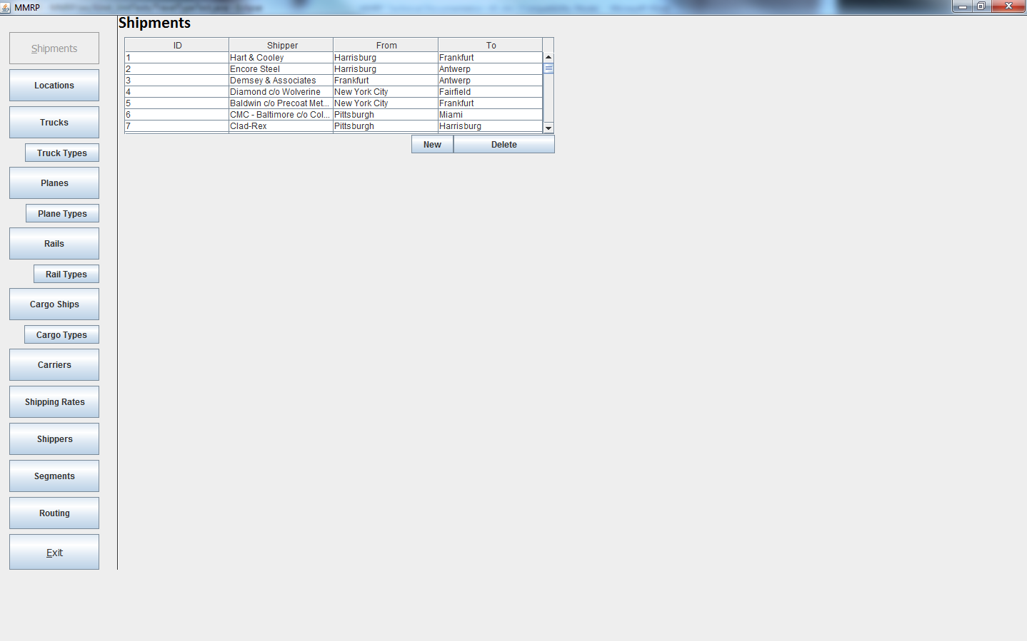

Figure 2

# 2.1 MMRP Objects

## 2.2.1 Vehicles

A Vehicle is a means to transport a Shipment from one Location to another. There are currently only four modes of transportation supported by the MMRP program. The supported modes are Truck, Cargo, Plane and Rail. Each Vehicle will have a Carrier. This Carrier owns the Vehicle and supplies it to the routing problem. Every Vehicle will also have a current Status. This Status will give a quick idea of how readily available a Vehicle is for use. The following sections will explains in greater detail the different modes of transportation available in the MMRP Program.

## 2.2.1.1 Trucks

A Truck is one of the four modes of transportation available in the MMRP program that can be used to transport a Shipment from one location to another. A Truck is a generalization of all the vehicles that use highways, roads and streets to get from one Location to another. A Truck will generally travel between Depots, but will also make the connecting stops at Ports, Stations, and Airports to link the travel modes together.

## 2.2.2.2 Cargo Ships

A Cargo Ship is one of the four modes of transportation available in the MMRP program that can be used to transport a Shipment from one location to another. A Cargo Ship is a generalization of all the vehicles that use ocean trade lanes and waterways to get from one Location to another. A Cargo Ship will generally travel between ports.

## 2.2.2.3 Planes

A Plane is one of the four modes of transportation available in the MMRP program that can be used to transport a Shipment from one location to another. A Plane is a generalization of all the vehicles that travel through the air to get from one location to another. A Plane will generally travel between airports.

## 2.2.2.4 Rails

A Rail is one of the four modes of transportation available in the MMRP program that can be used to transport a Shipment from one location to another. A Rail is a generalization of all the vehicles that travel by fixed tracks from one Location to another. A Rail will generally travel between Stations.

## 2.2.2 Locations

A Location is a place that the Shipment may stop at, either to switch Vehicles or because it is its point of origin or its destination. Every Location will have the information fields of its Country, State, City, Latitude and Longitude, along with which modes of transportation can reach this Location.

## 2.2.3 Segments

A Segment is a path between two Locations that the Shipment can travel along. The Segments are traversed by a particular Vehicle. Many Segments can exist between the same two Locations but they will be considered different because they have a different Vehicle that travels this path. The different Vehicles will mean these two Segments will have different times, costs and distances that the Shipment to consider for the routing. A path of Segments traversed in order from the Shipment's Start Location to its End Location is a routing solution. Every Segment has a Start and End Location, a Vehicle that travels this gap, estimated arrival and departure times, earliest arrival and departure times and latest arrival and departure times.

## 2.2.4 Shipping Rates

A Shipping Rate is a cost modifier that is supplied by a Carrier for a Segment. Each Carrier will have multiple Shipping Rates that it will supply along with its fleet of Vehicles. Different Shipping Rates will be applied over different Segments and will greatly affect the overall fiscal cost of using certain Segments and in turn will affect the routing possibilities. Each Shipping Rate will offer its own Flat Rate, Mile Rate, and three classes of Weight categories each with its own monetary Rate it the Shipment weighs over the given Weight.

## 2.2.5 Carriers

A Carrier is the company that owns the Vehicles that are supplied for the Segments. A Carrier also owns the Shipping Rates which determine how costly it is to use their Vehicles. Each Carrier will have its own Name, Carrier Code, Safety Rating, the date it was last rated, an Authorize value, a Contract Date, an Ins End Date, and optionally a Fax Number and Email Address.

## 2.2.6 Shipments

A Shipment is the package that needs to get from one Location to another via Routing. The Shipments sent by Shippers and are transported by a variety of Vehicles supplied from Carriers along potentially many Segments to reach their destination. Every Shipment will have a Start and End Location, a Priority, a Size, a Weight, an Earliest and Latest Arrival Time, an Earliest and Latest Departure Time, potentially a Shipment History, a Time To Load and Unload, a Shipper, a maximum number of stops, a Loading Rate, a Trailer Type, an Unloading and Loading Type, a list of Preferred Carriers, Hazardous Material Constraints, and options for taking Toll Roads and performing Congestion Bypass.

## 2.2.7 Shippers

A Shipper is the company that is sending a Shipment from one Location to another. Each Shipper has a Location or origin, a Company Name, a Contact Name, a Phone Number, an Email Address and a list of Preferred Carriers.

## 2.2.8 Travel Types

A Travel Type is a particular type of a Vehicle mode. For example a Log Carrier and a pick up Truck are both trucks but have very different properties. Each Travel Type has a Minimum Capacity, a Maximum Capacity, a Maximum Weight, a Service Type, and has options for 0-2 Trailers, Radiation transport, Refrigeration transport, Hazardous Material transport, Explosive transport, and Tracking information.

## 2.2.8.1 Truck Types

A Truck Type is the specific category of the Truck travel mode that a particular Vehicle is. This means that while two Vehicles might both be Trucks, one might be a pick-up Truck and the other may be a Log Carrier. This difference will give the two Trucks very different properties. These properties are captured in the Truck Type.

## 2.2.8.2 Cargo Types

A Cargo Type is the specific category of the Cargo travel mode that a particular Vehicle is. This means that while two Vehicles might both be Cargo Ships, one might be a small ferry Cargo Ship and the other may be an oil tanker. This difference will give the two Cargo Ships very different properties. These properties are captured in the Cargo Type.

## 2.2.8.3 Plane Types

A Plane Type is the specific category of the Plane travel mode that a particular Vehicle is. This means that while two Vehicles might both be Planes, one might be a small Cessna Plane and the other may be a Jumbo Jet. This difference will give the two Planes very different properties. These properties are captured in the Plane Type.

## 2.2.8.4 Rail Types

A Rail Type is the specific category of the Rail travel mode that a particular Vehicle is. This means that while two Vehicles might both be Rails, one might be a small 1 car locomotive and the other may be a high-speed bullet train. This difference will give the two Rails very different properties. These properties are captured in the Rail Type.

# 3. Exploring The Database

The MMRP Database is full of objects used in a routing problem. The Graphical User Interface (GUI) supplies a means to add, remove and explore the objects that have been saved to the database (DB). To view objects in the DB the MMRP program must first be running.

## 3.1 Exploring Vehicles

### 3.1.1 Exploring Trucks

To view a Truck that exists in the database follow these steps:

1. Click on the Trucks button on the left menu bar, pictured in Figure 3.
2. The trucks menu will be presented in the main viewing area, pictured in Figure 4.
3. From the truck menu clicking on a truck will load the information about the truck. Scroll the table until finding a truck, and then click on the truck. The tabbed truck editor panel will be displayed, shown in Figure 5.
   1. The basic tab will allow you to explore cursory information about the truck, this is what is shown in Figure 5.
   2. Clicking Segments will bring up the Segment Tab. This shows the segments that the truck operates on. This is shown in Figure 6.
   3. Clicking Types Shows the types that the truck is currently using against the types it is currently using. This is shown in Figure 7.

|  |  |
| --- | --- |
| Figure 3 | Figure 4 |

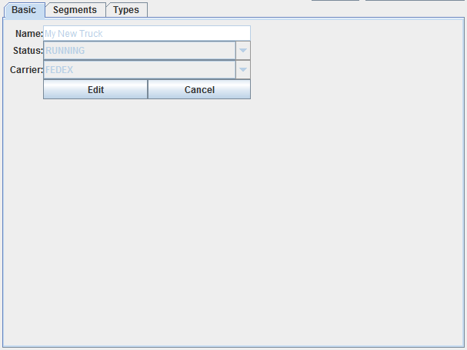

Figure 5

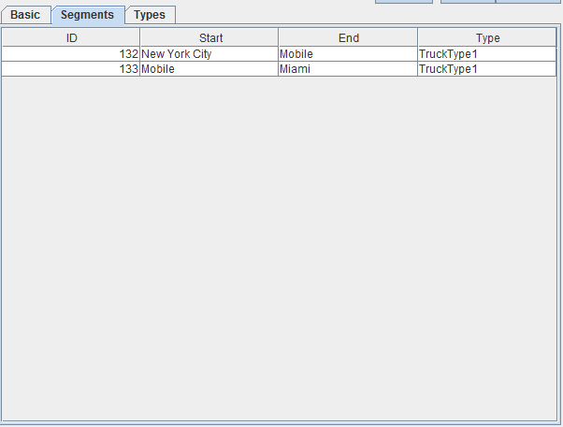

Figure 6

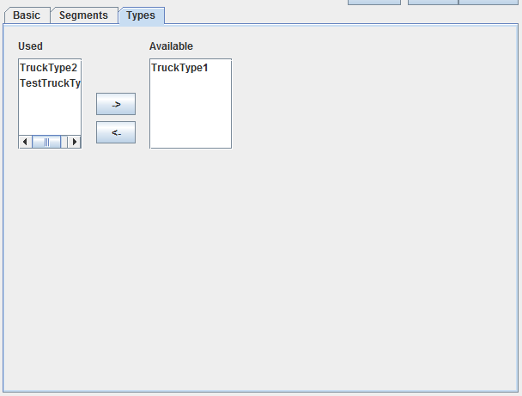

Figure 7

### 3.1.2 Exploring Cargo Ships

This works in the exact same was as exploring trucks. See section 3.1.1 for instructions on how to explore Cargo Ships.

### 3.1.3 Exploring Planes

This works in the exact same was as exploring trucks. See section 3.1.1 for instructions on how to explore Planes.

### 3.1.4 Exploring Rails

This works in the exact same was as exploring trucks. See section 3.1.1 for instructions on how to explore Rails.

## 3.2 Exploring Locations

To view a Location that exists in the database follow these steps:

1. Click on the Locations button on the left menu bar, shown in Figure 8.
2. The Location menu will be presented in the main viewing area, shown in Figure 9.

|  |  |
| --- | --- |
| Figure 8 | Figure 9 |

1. In the Location menu you can select any of the Locations in the database from the Location table. Scroll until you find the Location you want.
2. Select the desired Location. The Location Editor will appear displaying all the selected Location information, shown in Figure 10.

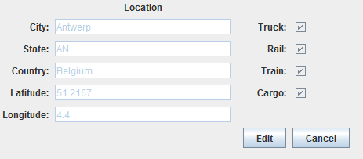

Figure 10

## 3.3 Exploring Segments

To view a Segment that exists in the database follow these steps:

1. Click on the Segments Button on the left menu bar, shown in Figure 11.
2. The Segments menu will be presented in the main viewing area, shown in Figure 12.

|  |  |
| --- | --- |
| Figure 11 | Figure 12 |

1. In the Segment menu you can select any of the Segments in the database from the Segment table. Scroll until you find the Segment you want.
2. Select the desired Segment. The Segment Editor will appear displaying all the selected segment information, shown in Figure 13.

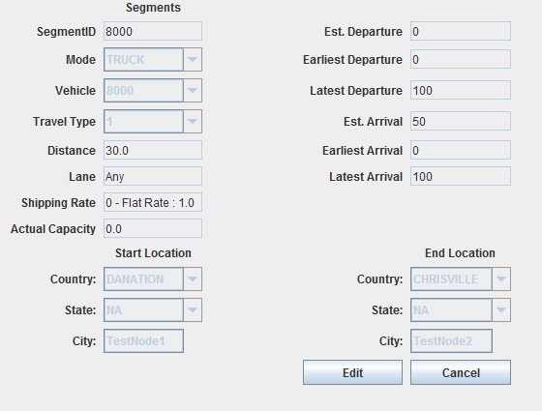

Figure 13

## 3.4 Exploring Shipping Rates

To view a Shipping Rate that exists in the database follow these steps:

1. Click on the Shipping Rate Button on the left menu bar, shown in Figure 14.
2. The Shipping Rate menu will be presented in the main viewing area, shown in Figure 15.

|  |  |
| --- | --- |
| Figure 14 | Figure 15 |

1. In the Shipping Rate menu you can select any of the Shipping Rates in the database from the Shipping Rate table. Scroll until you find the Shipping Rate you want.
2. Select the desired Shipping Rate. The Segment Editor will appear displaying all the selected Shipping Rate information, shown in Figure 16.

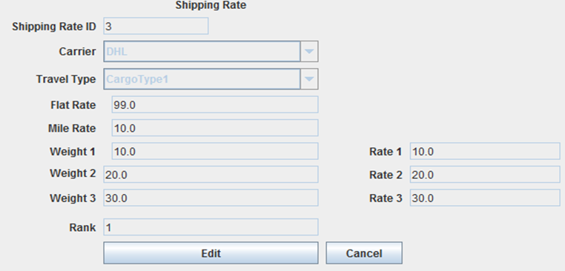

Figure 16

## 3.5 Exploring Carriers

To view a Carrier that exists in the database follow these steps:

1. Click on the Carrier Button on the left menu bar, shown in Figure 17.
2. The Carrier menu will be presented in the main viewing area, shown in Figure 18.

|  |  |
| --- | --- |
| Figure 17 | Figure 18 |

1. In the Carrier menu you can select any of the Carriers in the database from the Carrier table. Scroll until you find the Carrier you want.
2. Select the desired Carrier. The Carrier will appear displaying all the selected Carrier information, shown in Figure 19.

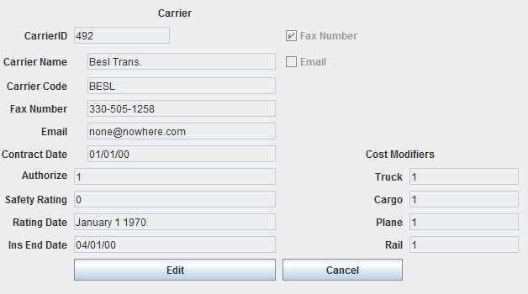

Figure 19

## 3.6 Exploring Shipments

To view a Shipment that exists in the database follow these steps:

1. Click on the Shipment button on the left menu bar, pictured in Figure 20.
2. The Shipment menu will be presented in the main viewing area, pictured in Figure 21.
3. From the Shipment menu clicking on a Shipment will load the information about the Shipment. Scroll the table until finding a Shipment, and then click on the truck. The tabbed Shipment editor panel will be displayed, shown in Figure 22.
   1. The info tab will allow you to explore cursory information about the Shipment, this is what is shown in Figure 22.
   2. Clicking History will bring up the History for the Segment, this is shown in Figure 23.

|  |  |
| --- | --- |
| Figure 20 | Figure 21 |

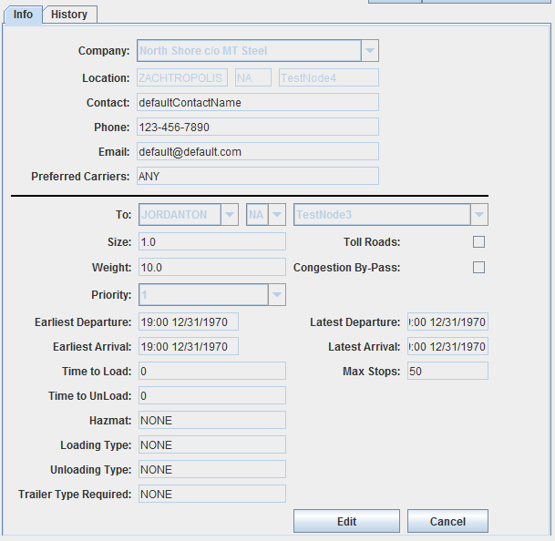

Figure 22

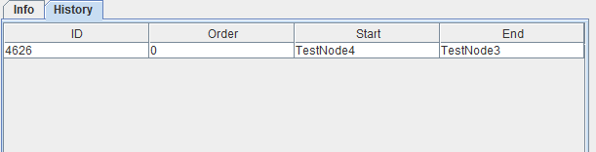

Figure 23

## 3.7 Exploring Shippers

To view a Shipper that exists in the database follow these steps:

1. Click on the Shipper Button on the left menu bar, shown in Figure 24.
2. The Shipper menu will be presented in the main viewing area, shown in Figure 25.

|  |  |
| --- | --- |
| Figure 24 | Figure 25 |

1. In the Shipper menu you can select any of the Shippers in the database from the Shipper table. Scroll until you find the Shipper you want.
2. Select the desired Shipper. The Shipper will appear displaying all the selected Shipper information, shown in Figure 26

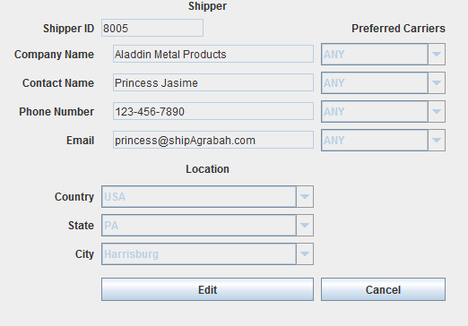

Figure 26

## 3.8 Exploring Travel Types

These next steps teach you how to explore the travel types in the database. This document will go into detail on exploring a Truck Type. All of the other types, Plane, Rail, and Cargo, function the exact same way. For brevity the topic will only be covered one time.

## 3.8.1 Exploring Truck Types

To view a Truck Type that exists in the database follow these steps:

1. Click on the Truck Type Button on the left menu bar, shown in Figure 27.
2. The Truck Type menu will be presented in the main viewing area, shown in Figure 28.

|  |  |
| --- | --- |
| Figure 27 | Figure 28 |

1. In the Truck Type menu you can select any of the Truck Types in the database from the Truck Type table. Scroll until you find the Truck Type you want.
2. Select the desired Truck Type. The Truck Type will appear displaying all the selected Truck Type information, shown in Figure 29.

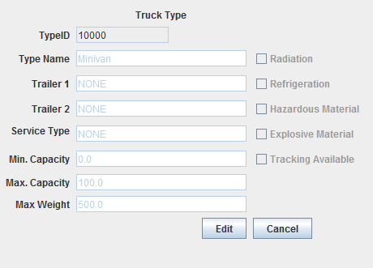

Figure 29

## 3.8.2 Exploring Cargo Types

This works in the exact same was as exploring Truck Types. See section 3.8.1 for instructions on how to explore Cargo Types.

## 3.8.3 Exploring Plane Types

This works in the exact same was as exploring Truck Types. See section 3.8.1 for instructions on how to explore Plane Types.

## 3.8.4 Exploring Rail Types

This works in the exact same was as exploring Truck Types. See section 3.8.1 for instructions on how to explore Rail Types.

# 4. Adding Objects To The Database

The MMRP Database is capable of using user-defined objects for use in its routing solutions. You can add the following objects to the database by following the steps listed below.

## 4.1 Adding Vehicles

### 4.1.1 Adding Trucks

Adding objects to the database is done the same way for each object type. For brevity this document will only go into details on adding a Vehicle (Truck) to the database. To add a new Truck to the database follow these steps:

1. Click on the Trucks button on the left menu bar, pictured in Figure 3.
2. The trucks menu will be presented in the main viewing area, pictured in Figure 4.
3. Click on the New Button, seen in picture 30. Regardless of which tab you are using it will take you to the basic tab.



Figure 30

1. Enter values for all of the fields, see Figure 31.
   1. Enter a String Value for the Name.
   2. Select an available status from the Status drop down.
   3. Select an available Carrier from the Carrier drop down.

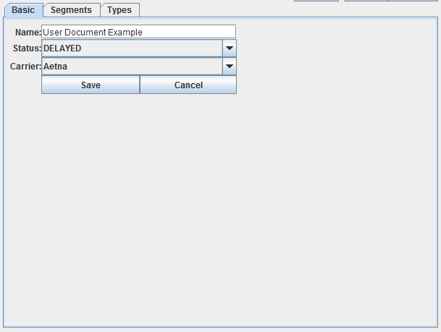

Figure 31

* 1. Click Save.

1. Click Types Tab, Figure 7.
   1. Add desired Types from the available Menu and move them over to used using the <- arrow, Figure 32.
   2. Any Used Types that need removed can be done by clicking on them and then clicking ->, Figure 33.

|  |  |  |
| --- | --- | --- |
|  |  |  |

Figure 32

|  |  |  |
| --- | --- | --- |
|  |  |  |

Figure 33

1. Click Basic tab.
2. Click Save.

### 4.1.2 Adding Cargo Ships

Cargo Ships are added in the exact same fashion as Trucks. For instructions on adding a Cargo Ship see Section 4.1.1 Adding Trucks.

## 4.1.3 Adding Planes

Planes are added in the exact same fashion as Trucks. For instructions on adding a Cargo Ship see Section 4.1.1 Adding Trucks.

## Adding Rail

Rails are added in the exact same fashion as Trucks. For instructions on adding a Cargo Ship see Section 4.1.1 Adding Trucks.

## 4.2 Adding Locations

To add a new Location to the database follow these steps:

1. Click on the Locations button on the left menu bar.
2. Click on the New button. The empty Location Editor will appear, seen in Figure 34.
3. Enter data into all of the fields, seen in Figure 35.
   1. Checkboxes do not have to be checked.
   2. Truck will be checked by default as all locations have trucks.
4. Click Save.

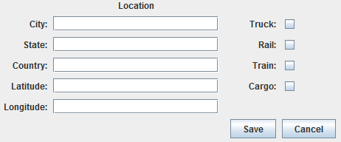

Figure 34

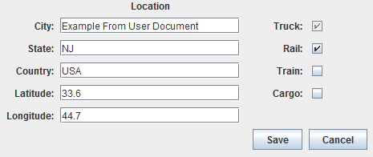

Figure 35

## 4.3 Adding Segments

To add a new Segment to the database follow these steps:

1. Click on the Segments button on the left menu bar.
2. Click on the New button. The empty Segment Editor will appear, Figure 36.

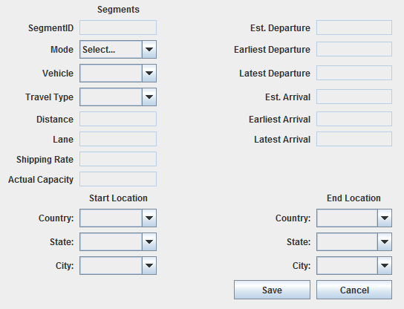

Figure 36

1. Enter data into all of the fields in the following order:
   1. Select the Mode, this populates the Vehicles available drop down.
   2. Select at Vehicle, this populates the Travel Type Vehicle.
   3. Select a Travel Type.
   4. Select Starting Location and Ending Location.
      1. Select the Country first, this populates the State dropdown.
      2. Select the State next, this populates the City dropdown.
      3. Select the City.
   5. The distance should auto-populate based on the Locations selected.
   6. The Lane takes any String value. This is incorporated for future work.
   7. Select a Shipping Rate from the drop down.
   8. Enter the actual capacity that the Vehicle will have over the Segment.
   9. Enter Values in the format HH:MM MM/DD/YYYY for the following fields:
      1. Est. Departure
      2. Earliest Departure
      3. Latest Departure
      4. Est. Arrival
      5. Earliest Arrival
      6. Latest Arrival
   10. Click Save.

## 4.4 Adding Shipping Rates –Dan Start Here Tonight.

To add a new Shipping Rate to the database follow these steps

* + - * 1. Click on the Shipping Rates button on the left menu bar.
        2. 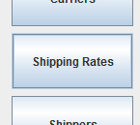Beneath the Shipping Rates Table click on the New Button
        3. The Shipping Rate Editor will appear in the main viewing area

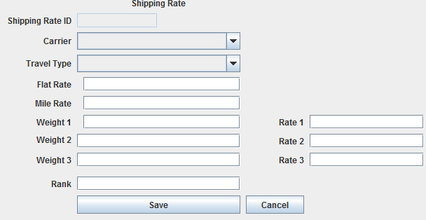

* + - * 1. Select a Carrier for the Shipping Rate from the Carrier dropbox.
        2. Select a Travel Type for the Shipping Rate from the Travel Type dropbox
        3. Enter valid values into the following fields

Flat Rate – This is the base fee for transportation. This can be any value over 0



Mile Rate – This is the amount that is charged per mile travelled. This rate can be anything over 0.



Weight 1 – This is the weight for under which only the Flat Rate and Mile Rate will apply.



Weight 2 – This is the upper bound for which Rate 1 will apply



Weight 3 – This is the upper bound for which Rate 2 will apply



Rate 1 – This is the additional charge that will be applied for Shipments weighing between Weight 1 and Weight 2



Rate 2 – This is the additional charge that will be applied for Shipments weighing between Weight 2 and Weight 3



Rate 3 – This is the additional charge that will be applied for Shipments weighing over Weight 3.



Rank – This is a number between 0 and 10.



* + - * 1. Click Save



* + - * 1. The new Shipping Rate is now added to the database and can be used in future routing solutions.

**4.5 Adding Carriers**

To add a new Carrier to the database follow these steps

* + - * 1. Click on the Carriers button on the left menu bar.

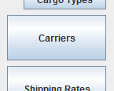

* + - * 1. Beneath the Carriers Table click on the New Button



* + - * 1. The Carrier Editor will appear in the main viewing area
        2. 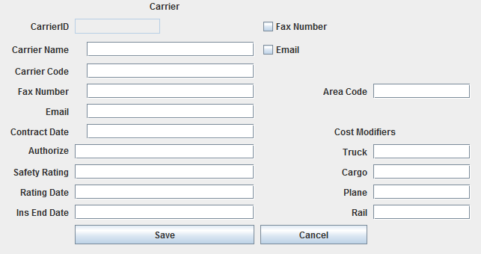Enter valid values into the following fields

Carrier Name – This is the name of the Carrier company. It can consist of 1-45 alphabetical characters.

Carrier Code – This is the short hand code for the Carrier. It can consist of 1-4 alphanumeric characters.

Fax Number – This is the company fax number. It should be presented in the following ten digit format, “### - ### - #####”



Email – This is the email address that the Carrier can be reached at. It should be entered in the following format, “(any alphanumeric characters)@(any alphanumeric character).(2-4 alphabetical characters)”



Contract Date – This is the date the contract was validated. It should be entered in the following format, “MM/dd/YYYY”



Authorize – This is a value between 0 and 10



Safety Rating – This is a value representing how safety they have performed their task of handling Shipments. This value should be between 0 and 100.



Rating Date – This is the date that they received their last safety evaluation. It should be in the following format, “MM/dd/YYYY”



Ins End Date – This date should be in the following format, “MM/dd/YYYY”



Fax Number Checkbox – check this box if this Carrier can be reached via a fax machine



Email Checkbox – check this box if this Carrier can be reached via an email address.



Area Code – This is the area code for the phone number which the Carrier can be reached at. It should be three numbers long



Cost Modifiers – These are available to change the standard costs associated with the types of Vehicles this Carrier supplies

Truck – This value will modify the costs of using this Carrier's Trucks. This should be a value between 0 and 100.



Cargo – This value will modify the costs of using this Carrier's Cargos. This should be a value between 0 and 100.



Plane – This value will modify the costs of using this Carrier's Planes. This should be a value between 0 and 100.



Rail – This value will modify the costs of using this Carrier's Rails. This should be a value between 0 and 100.



* + - * 1. Click Save



* + - * 1. The new Carrier is now added to the database and can be used in future routing solutions.

**4.6 Adding Shipments**

To add a new Shipment to the database follow these steps

* + - * 1. Click on the Shipments button on the left menu bar.

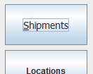

* + - * 1. The Shipment Menu will appear
        2. 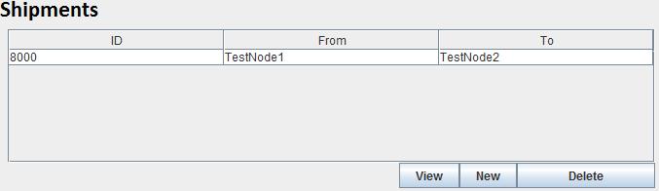Click on the New button on the right, under the Shipments Table
        3. The blank Shipment Editor will appear in the main viewing area

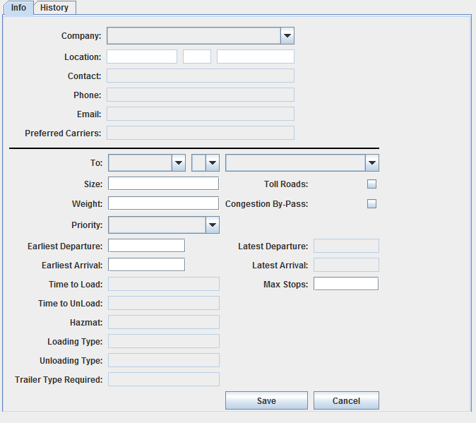

* + - * 1. Select a Shipper from the Company dropbox



* + - * 1. Once selected the Shipper's information will populate the Shipper information window

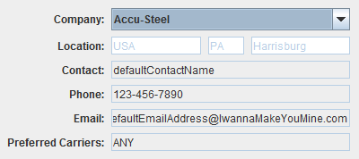

* + - * 1. Select an End Location using the Country, State and City dropboxs. For more information on how to do this see Section 3.2 'Exploring Locations'



* + - * 1. Enter valid values in the following fields

Size – this is the volumetric size of the Shipment in meters cubed. This value should be greater than 0.

Weight – this is how much the Shipment weighs in kilograms. This value should be greater than 0.

Priority – this is how important the Shipment is. The higher the Priority the more important the Shipment. The dropbox values range from 1 to 10.

Earliest Departure Time – This is the earliest time that a Shipment can leave its Start Location. The format should be “HH:mm MM/dd/YYYY” usign a 24-hour clock.

Latest Departure Time – This is the latest time that a Shipment can leave its Start Location. The format should be “HH:mm MM/dd/YYYY” usign a 24-hour clock. This is currently not supported.

Earliest Arrival Time – This is the earliest time that a Shipment can arrive at its End Location. The format should be “HH:mm MM/dd/YYYY” usign a 24-hour clock.

Latest Arrival Time – This is the latest time that a Shipment can arrive at its End Location. The format should be “HH:mm MM/dd/YYYY” usign a 24-hour clock. This is currently not supported.

Time To Load – This is the estimated time it will take to load the Shipment onto a Vehicle. This is currently unsupported and should be set to 0.

Time To Unload – This is the estimated time it will take to unload the Shipment from a Vehicle. This is currently unsupported and should be set to 0.

Hazmat – This is a list of the hazardous material constraints that need to be considered when handling this Shipment. This is currently unsupported and should be set to “NONE”

Loading Type – This is the type of loading that is required to get a Shipment onto a Vehicle. For example a crane may be needed. This is currently unsupported and should be set to “NONE”

Unloading Type – This is the type of unloading that is required to remove a Shipment from a Vehicle. For example a crane may be needed. This is currently unsupported and should be set to “NONE”

Trailer Type Required - This is the type of trailer that will be needed to transport a Shipment. This is currently unsupported and should be set to “NONE”.

Toll Roads – Check this box is the Shipment is allowed to take toll roads. This is currently not supported.

Congestion By-Pass – Check this box is the Shipment is allowed to attempt to by-pass congested routes. This is currently not supported.

* + - * 1. Click Save
        2. The new Shipment will be added to the database and can be routed.

**4.7 Adding Shippers**

To add a new Shipper to the database follow these steps

* + - * 1. Click on the Shippers button on the left menu bar.
        2. 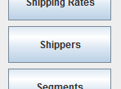Click on the New button on the right, under the Shippers Table
        3. 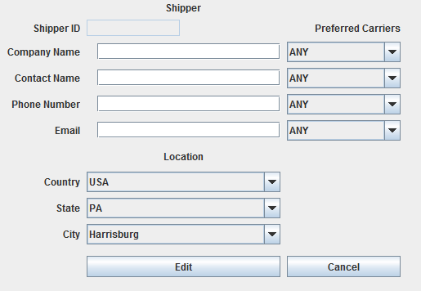The blank Shipper Editor will appear in the main viewing area
        4. Select a Location using the Country, State and City dropboxs. For more information on how to do this see Section 3.2 'Exploring Locations'
        5. Enter valid values in the following fields

Company Name – This is the company name of the Shipper. This field should have between 1 and 45 alphanumeric characters



Contact Name – This is the individual that can be reached using the contact information. This field should have bettern 1 and 45 alphabetical characters



Phone Number – This is the number that the Shipper can be reached at. This field should be in the following format, “###-###-####”.

Email – This is the email address that the Shipper can be reached at. This field should be in the following format, “(any alphanumeric characters)@(any alphanumeric characters).(2-4 alphabetic characters)



Preferred Carriers – Select up to 4 preferred carriers that the Shippers will use for sending Shipments. This is currently not supported and will be set to “ANY”

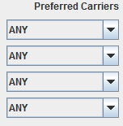

* + - * 1. Click Save



* + - * 1. The new Shipper will be added to the database and can be used for future routing.

**4.8 Adding Travel Types**

**4.8.1 Adding Truck Types**

To add a new Truck Type to the database follow these steps

* + - * 1. Click on the Truck Types button on the left menu bar.
        2. 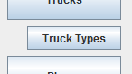The Truck Types menu will appear.

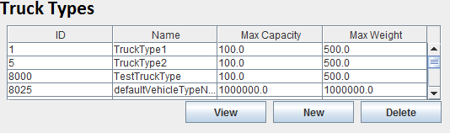

* + - * 1. Click on the New button on the right, under the Truck Types Table



* + - * 1. The blank Truck Type Editor will appear in the main viewing area

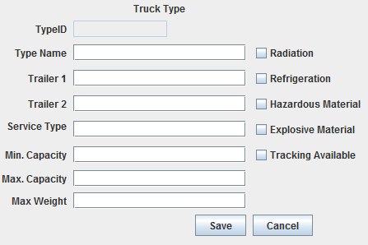

* + - * 1. Enter valid values in the following fields

Type Name – This is the new name of the travel type you are creating. It should consist of 1-45 alphanumeric characters.

Trailer 1 – This is currently not supported.

Trailer 2 – This is currently not supported.

Service Type – This is currently not supported

Min. Capacity – This is the minimum capacity that this travel type must be filled to leave its location. This value must be greater than or equal to zero.

Max. Capacity- This is the maximum capacity that this travel type can be filled to. This value must be greater than or equal to the Min. Capacity value.

Max. Weight – This is the maximum weight this travel type can transport. This value must be greater than or equal to zero.

Radiation – Check this box if this travel type can handle radioactive shipments.

Refrigeration – Check this box if this travel type can handle refrigerated shipments.

Hazardous Material – Check this box if this travel type can handle hazardous shipments.

Explosive Material – Check this box if this travel type can handle explosive shipments.

Tracking Available – Check this box if this travel type has tracking available for it.

* + - * 1. Click Save
        2. The new Truck Type will be added to the database and can be used for future routing.

**4.8.2 Adding Cargo Types**

To add a new Cargo Type to the database follow these steps

* + - * 1. Click on the Cargo Types button on the left menu bar.
        2. 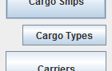The Cargo Types Menu will appear.

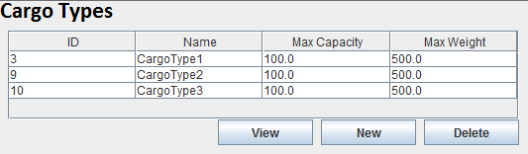

* + - * 1. Click on the New button on the right, under the Cargo Types Table



* + - * 1. 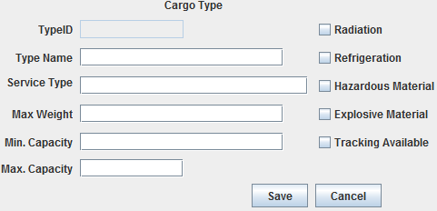The blank Cargo Type Editor will appear in the main viewing area
        2. Enter valid values in the following fields

Type Name – This is the new name of the travel type you are creating. It should consist of 1-45 alphanumeric characters.

Trailer 1 – This is currently not supported.



Trailer 2 – This is currently not supported.

Service Type – This is currently not supported

Min. Capacity – This is the minimum capacity that this travel type must be filled to leave its location. This value must be greater than or equal to zero.

Max. Capacity- This is the maximum capacity that this travel type can be filled to. This value must be greater than or equal to the Min. Capacity value.

Max. Weight – This is the maximum weight this travel type can transport. This value must be greater than or equal to zero.

Radiation – Check this box if this travel type can handle radioactive shipments.

Refrigeration – Check this box if this travel type can handle refrigerated shipments.

Hazardous Material – Check this box if this travel type can handle hazardous shipments.

Explosive Material – Check this box if this travel type can handle explosive shipments.

Tracking Available – Check this box if this travel type has tracking available for it.

* + - * 1. Click Save
        2. The new Cargo Type will be added to the database and can be used for future routing.

**4.8.3 Adding Plane Types**

To add a new Plane Type to the database follow these steps

* + - * 1. Click on the Plane Types button on the left menu bar.

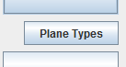

* + - * 1. The Plane Types Menu will appear.

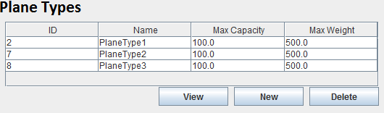

* + - * 1. Click on the New button on the right, under the Plane Types Table



* + - * 1. The blank Plane Type Editor will appear in the main viewing area

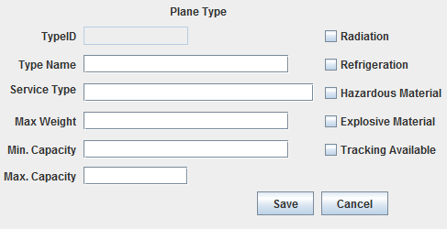

* + - * 1. Enter valid values in the following fields

Type Name – This is the new name of the travel type you are creating. It should consist of 1-45 alphanumeric characters.

Trailer 1 – This is currently not supported.



Trailer 2 – This is currently not supported.

Service Type – This is currently not supported

Min. Capacity – This is the minimum capacity that this travel type must be filled to leave its location. This value must be greater than or equal to zero.

Max. Capacity- This is the maximum capacity that this travel type can be filled to. This value must be greater than or equal to the Min. Capacity value.

Max. Weight – This is the maximum weight this travel type can transport. This value must be greater than or equal to zero.

Radiation – Check this box if this travel type can handle radioactive shipments.

Refrigeration – Check this box if this travel type can handle refrigerated shipments.

Hazardous Material – Check this box if this travel type can handle hazardous shipments.

Explosive Material – Check this box if this travel type can handle explosive shipments.

Tracking Available – Check this box if this travel type has tracking available for it.

* + - * 1. Click Save
        2. The new Plane Type will be added to the database and can be used for future routing.

**4.8.4 Adding Rail Types**

To add a new Rail Type to the database follow these steps

* + - * 1. Click on the Rail Types button on the left menu bar.

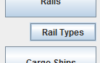

* + - * 1. The Rail Types Menu will appear.

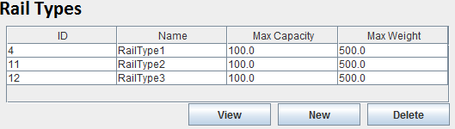

* + - * 1. Click on the New button on the right, under the Rail Types Table



* + - * 1. The blank Rail Type Editor will appear in the main viewing area

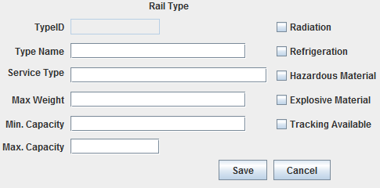

* + - * 1. Enter valid values in the following fields

Type Name – This is the new name of the travel type you are creating. It should consist of 1-45 alphanumeric characters.

Trailer 1 – This is currently not supported.



Trailer 2 – This is currently not supported.

Service Type – This is currently not supported

Min. Capacity – This is the minimum capacity that this travel type must be filled to leave its location. This value must be greater than or equal to zero.

Max. Capacity- This is the maximum capacity that this travel type can be filled to. This value must be greater than or equal to the Min. Capacity value.

Max. Weight – This is the maximum weight this travel type can transport. This value must be greater than or equal to zero.

Radiation – Check this box if this travel type can handle radioactive shipments.

Refrigeration – Check this box if this travel type can handle refrigerated shipments.

Hazardous Material – Check this box if this travel type can handle hazardous shipments.

Explosive Material – Check this box if this travel type can handle explosive shipments.

Tracking Available – Check this box if this travel type has tracking available for it.

* + - * 1. Click Save
        2. The new Rail Type will be added to the database and can be used for future routing.

**5. Editing Objects In The Database**

The MMRP Database pbjects can be modified in many ways to model changes in the real world, or to better suit the needs of the user. To modify existing database objects follow the steps below.

**5.1 Editing Vehicles**

**5.1.1 Editing Trucks**

To edit an existing Truck in the database follow these steps

* + - * 1. Click on the Trucks button on the left menu bar.
        2. 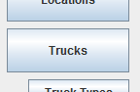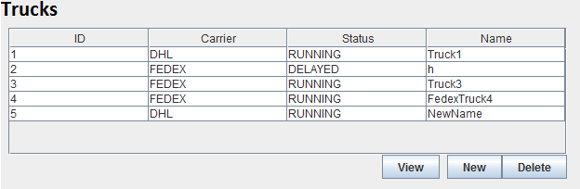The Trucks table will then appear in the main area
        3. Find the Truck you wish to edit on the Truck table
        4. Select the desired Truck from the list
        5. Click on the View button
        6. 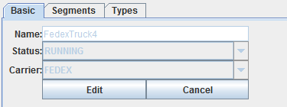The Truck Tabbed Editor will appear below the Trucks Table
        7. Click on the Edit Button in the Basic tab
        8. The Truck's values can now be modified

**5.1.1.1 Changing A Truck`s Name**

* + - * 1. The Name field can be found in the Basic Tab of the Truck Tabbed Editor
        2. Enter a new name for the Truck between 1 and 45 alphanumeric characters.
        3. If you enter an invalid name an error message will appear.
        4. Once you are satisfied with the new name click the Save button
        5. The new name will be updated in the Trucks Table and in the database.

**5.1.1.2 Changing A Truck`s Status**

* + - * 1. The Status dropbox can be found in the Basic Tab of the Truck Tabbed Editor
        2. Click on the dropbox and select a new Status for the Truck.
        3. The currently supported Status states are:

RUNNING – The vehicle is operating normally and is on time.

DELAYED – The vehicle is operating normally but is running late.

DISABLED – The vehicle is not operating.

* + - * 1. Click Save
        2. The new Status will be updated in the Trucks Table and in the database.

**5.1.1.3 Changing A Truck`s Carrier**

* + - * 1. The Carrier dropbox can be found in the Basic Tab of the Truck Tabbed Editor
        2. Click on the dropbox and select a new Carrier for the Truck.
        3. The Carrier dropbox will be populated with all the Carriers in the database.
        4. Click Save
        5. The new Carrier will be updated in the Trucks Table and in the database.

**5.1.1.4 Changing A Truck`s Available Types**

**5.1.1.4.1 Adding Types**

Click on the Types tab of the Truck Tabbed Editor

The Types menu will appear.

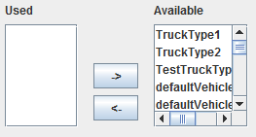Click on the Truck type you wish to make available from the Available list.

Once selected click on the left pointing arrow

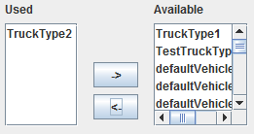The selected Truck Type will move to the Used list and will be available for use by this Truck

This change will be saved in the database

**5.1.1.4.2 Removing Types**

Click on the Types tab of the Truck Tabbed Editor

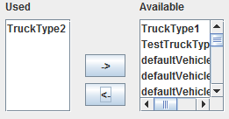The Types menu will appear.

Click on the Truck type you wish to make unavailable from the Used list.

Once selected click on the right pointing arrow

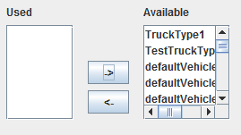The selected Truck Type will move to the Available list and will no longer be available for this Truck

This change will be saved in the database

**5.1.2 Editing Cargo Ships**

To edit an existing Cargo Ship in the database follow these steps

* + - * 1. Click on the Cargo Ship button on the left menu bar.
        2. 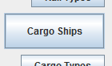The Cargo Ships table will then appear in the main area
        3. 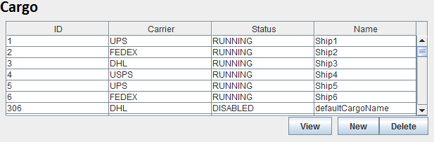Find the Cargo Ship you wish to edit on the Cargo Ship table
        4. Select the desired Cargo Ship from the list
        5. Click on the View button
        6. 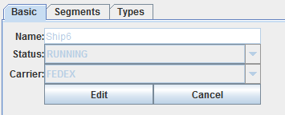The Cargo Ship Tabbed Editor will appear below the Cargo Ships Table
        7. Click on the Edit Button in the Basic tab
        8. The Cargo Ship's values can now be modified

**5.1.2.1 Changing A Cargo Ships Name**

* + - * 1. The Name field can be found in the Basic Tab of the Cargo Ship Tabbed Editor
        2. Enter a new name for the Cargo Ship between 1 and 45 alphanumeric characters.
        3. If you enter an invalid name an error message will appear.
        4. Once you are satisfied with the new name click the Save button
        5. The new name will be updated in the Cargo Ships Table and in the database.

**5.1.2.2 Changing A Cargo Ship's Status**

* + - * 1. The Status dropbox can be found in the Basic Tab of the Cargo Ship Tabbed Editor
        2. Click on the dropbox and select a new Status for the Cargo Ship.
        3. The currently supported Status states are:

RUNNING – The vehicle is operating normally and is on time.

DELAYED – The vehicle is operating normally but is running late.

DISABLED – The vehicle is not operating.

* + - * 1. Click Save
        2. The new Status will be updated in the Cargo Ships Table and in the database.

**5.1.2.3 Changing A Cargo Ship's Carrier**

* + - * 1. The Carrier dropbox can be found in the Basic Tab of the Cargo Ship Tabbed Editor
        2. Click on the dropbox and select a new Carrier for the Cargo Ship.
        3. The Carrier dropbox will be populated with all the Carriers in the database.
        4. Click Save
        5. The new Carrier will be updated in the Cargo Ships Table and in the database.

**5.1.2.4 Changing A Cargo Ship's Available Types**

**5.1.2.4.1 Adding Types**

Click on the Types tab of the Cargo Ship Tabbed Editor

The Types menu will appear.

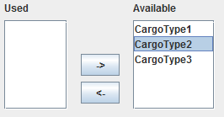Click on the Cargo Ship type you wish to make available from the Available list.

Once selected click on the left pointing arrow

The selected Cargo Ship Type will move to the Used list and will be available for use by this Cargo Ship

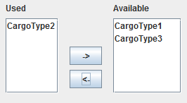This change will be saved in the database

**5.1.2.4.2 Removing Types**

Click on the Types tab of the Cargo Ship Tabbed Editor

The Types menu will appear.

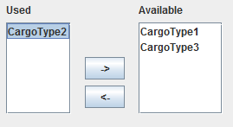

Click on the Cargo Ship type you wish to make unavailable from the Used list.

Once selected click on the right pointing arrow

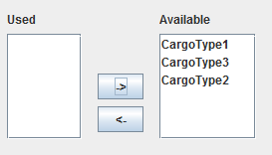The selected Cargo Ship Type will move to the Available list and will no longer be available for this Cargo Ship

This change will be saved in the database

**5.1.3 Editing Planes**

To edit an existing Plane in the database follow these steps

* + - * 1. 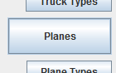Click on the Planes button on the left menu bar.
        2. 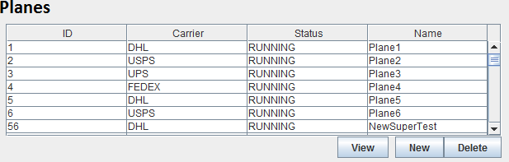The Planes table will then appear in the main area
        3. Find the Plane you wish to edit on the Plane table
        4. Select the desired Plane from the list
        5. Click on the View button
        6. The Plane Tabbed Editor will appear below the Planes Table

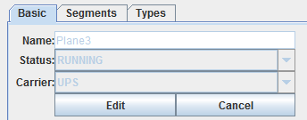

* + - * 1. Click on the Edit Button in the Basic tab
        2. The Plane's values can now be modified

**5.1.3.1 Changing A Plane's Name**

* + - * 1. The Name field can be found in the Basic Tab of the Plane Tabbed Editor
        2. Enter a new name for the Plane between 1 and 45 alphanumeric characters.
        3. If you enter an invalid name an error message will appear.
        4. Once you are satisfied with the new name click the Save button
        5. The new name will be updated in the Plane Table and in the database.

**5.1.3.2 Changing A Plane's Status**

* + - * 1. The Status dropbox can be found in the Basic Tab of the Plane Tabbed Editor
        2. Click on the dropbox and select a new Status for the Plane.
        3. The currently supported Status states are:

RUNNING – The vehicle is operating normally and is on time.

DELAYED – The vehicle is operating normally but is running late.

DISABLED – The vehicle is not operating.

* + - * 1. Click Save
        2. The new Status will be updated in the Plane s Table and in the database.

**5.1.3.3 Changing A Plane's Carrier**

* + - * 1. The Carrier dropbox can be found in the Basic Tab of the Plane Tabbed Editor
        2. Click on the dropbox and select a new Carrier for the Plane.
        3. The Carrier dropbox will be populated with all the Carriers in the database.
        4. Click Save
        5. The new Carrier will be updated in the Planes Table and in the database.

**5.1.3.4 Changing A Plane's Available Types**

**5.1.3.4.1 Adding Types**

Click on the Types tab of the Plane Tabbed Editor

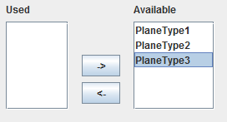The Types menu will appear.

Click on the Plane type you wish to make available from the Available list.

Once selected click on the left pointing arrow

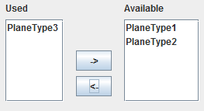The selected Plane Type will move to the Used list and will be available for use by this Plane.

This change will be saved in the database

**5.1.3.4.2 Removing Types**

Click on the Types tab of the Plane Tabbed Editor

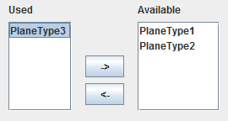The Types menu will appear.

Click on the Plane type you wish to make unavailable from the Used list.

Once selected click on the right pointing arrow

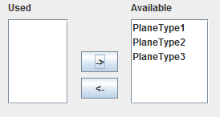The selected Plane Type will move to the Available list and will no longer be available for this Plane.

This change will be saved in the database

**5.1.4 Editing Rails**

To edit an existing Rail in the database follow these steps

* + - * 1. Click on the Rails button on the left menu bar.
        2. 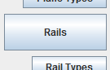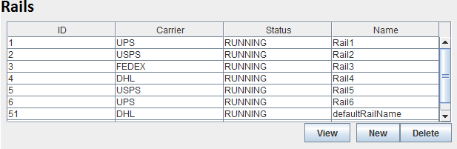The Rails table will then appear in the main area
        3. Find the Rail you wish to edit on the Rail table
        4. Select the desired Rail from the list
        5. Click on the View button
        6. The Rail Tabbed Editor will appear below the Rails Table

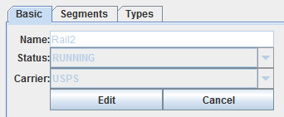

* + - * 1. Click on the Edit Button in the Basic tab
        2. The Rail's values can now be modified

**5.1.4.1 Changing A Rail's Name**

* + - * 1. The Name field can be found in the Basic Tab of the Rail Tabbed Editor
        2. Enter a new name for the Rail between 1 and 45 alphanumeric characters.
        3. If you enter an invalid name an error message will appear.
        4. Once you are satisfied with the new name click the Save button
        5. The new name will be updated in the Rail Table and in the database.

**5.1.4.2 Changing A Rail's Status**

* + - * 1. The Status dropbox can be found in the Basic Tab of the Rail Tabbed Editor
        2. Click on the dropbox and select a new Status for the Rail.
        3. The currently supported Status states are:

RUNNING – The vehicle is operating normally and is on time.

DELAYED – The vehicle is operating normally but is running late.

DISABLED – The vehicle is not operating.

* + - * 1. Click Save
        2. The new Status will be updated in the Rails Table and in the database.

**5.1.4.3 Changing A Rail's Carrier**

* + - * 1. The Carrier dropbox can be found in the Basic Tab of the Rail Tabbed Editor
        2. Click on the dropbox and select a new Carrier for the Rail.
        3. The Carrier dropbox will be populated with all the Carriers in the database.
        4. Click Save
        5. The new Carrier will be updated in the Rails Table and in the database.

**5.1.4.4 Changing A Rail's Available Types**

**5.1.4.4.1 Adding Types**

Click on the Types tab of the Rail Tabbed Editor

The Types menu will appear.

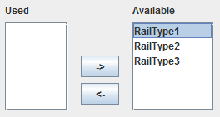Click on the Rail type you wish to make available from the Available list.

Once selected click on the left pointing arrow

The selected Rail Type will move to the Used list and will be available for use by this Rail.

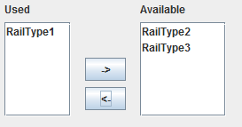

This change will be saved in the database

**5.1.4.4.2 Removing Types**

Click on the Types tab of the Rail Tabbed Editor

The Types menu will appear.

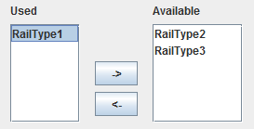

Click on the Rail type you wish to make unavailable from the Used list.

Once selected click on the right pointing arrow

The selected Rail Type will move to the Available list and will no longer be available for this Rail.

This change will be saved in the database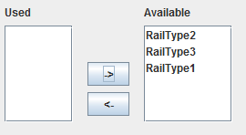

**5.2 Editing Locations**

To edit an existing Location in the database follow these steps

* + - * 1. 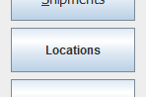Click on the Locations button on the left menu bar.
        2. The Location Menu will appear
        3. 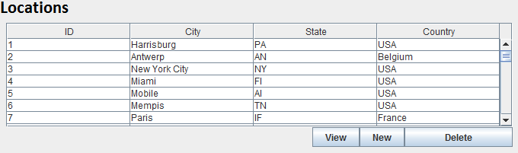Select a Location from the Locations Table.
        4. Click View
        5. The Location Editor will appear below the Locations Table and be populated with the selected Location's information.
        6. 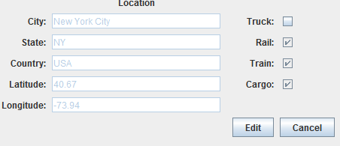Click Edit



* + - * 1. The Location's values are now modifiable.

**5.2.1 Changing the Location's Country**

* + - * 1. The Country field will accept any alphabetic string from 1-45 characters long



* + - * 1. If an invalid entry is made an error message will appear
        2. Click Save
        3. The new Country for this Location will be updated in the database.

**5.2.2 Changing the Location's State**

* + - * 1. The State field will accept any alphabetic string from 1-45 characters long



* + - * 1. If an invalid entry is made an error message will appear
        2. Click Save
        3. The new State for this Location will be updated in the database.

**5.2.3 Changing the Location's City**

* + - * 1. The City field will accept any alphabetic string from 1-45 characters long



* + - * 1. If an invalid entry is made an error message will appear
        2. Click Save
        3. The new City for this Location will be updated in the database.

**5.2.4 Changing the Location's Latitude**

* + - * 1. The Latitude field will accept any numeric value between -90.0 degrees and 90.0 degrees
        2. If an invalid entry is made an error message will appear
        3. Click Save
        4. The new Latitude for this Location will be updated in the database.

**5.2.5 Changing the Location's Longitude**

* + - * 1. The Longitude field will accept any numeric value between -180.0 degrees and 180.0 degrees



* + - * 1. If an invalid entry is made an error message will appear
        2. Click Save
        3. The new Longitude for this Location will be updated in the database.

**5.2.6 Changing the Location's Travel Modes**

* + - * 1. Check the checkboxes of the travel modes that can reach this Location
        2. Uncheck the checkboxes of the travel modes that can not reach this Location.
        3. Once the desired modes of travel have been checked, click Save.
        4. The new Travel Modes for this Location will be updated in the database.

**5.3 Editing Segments**

To edit an existing Segment in the database follow these steps

* + - * 1. Click on the Segments button on the left menu bar.
        2. 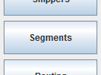The Segment Menu will appear
        3. 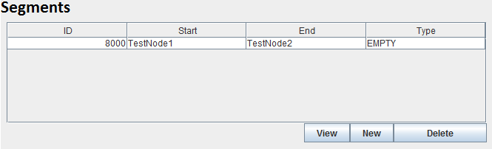Select the Segment you wish to modify from the Segment Table
        4. Click the View button
        5. The Segment Editor will appear below the Segment Table
        6. 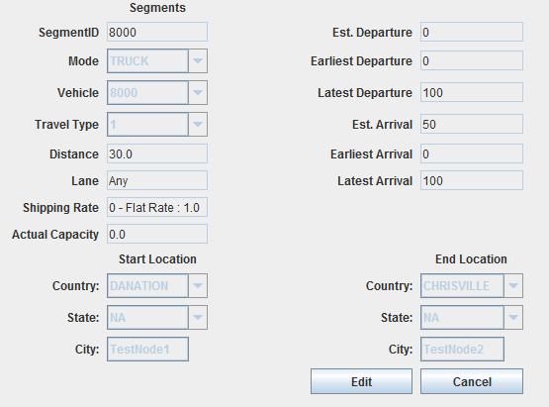Click Edit



* + - * 1. The Segment's fields will now be modifiable.

**5.3.1 Changing the Segment's Mode**

* + - * 1. Select a new Travel Mode from the Travel Modes dropbox
        2. Click Save
        3. The new Travel Mode for this Segment will be updated in the database.

**5.3.2 Changing the Segment's Vehicle**

* + - * 1. Select a new Vehicle from the Vehicle dropbox
        2. Click Save
        3. The new Vehicle for this Segment will be updated in the database.

**5.3.3 Changing the Segment's Travel Type**

* + - * 1. Select a new Travel Type from the Travel Type dropbox
        2. Click Save
        3. The new Travel Type for this Segment will be updated in the database.

**5.3.4 Changing the Segment's Lane -CURRENTLY UNSUPPORTED**

* + - * 1. The Lane field will accept any alphabetic string from 1-45 characters long
        2. If an invalid entry is made an error message will appear
        3. Click Save
        4. The new Lane for this Segment will be updated in the database

**5.3.5 Changing the Segment's Shipping Rate**

* + - * 1. Select a new Shipping Rate from the Shipping Rate drop box
        2. Click Save
        3. The new Shipping Rate for this Segment will be updated in the database.

**5.3.6 Changing the Segment's Departure Time**

**5.3.6.1 Changing the Segment's Estimated Departure Time**

Type in a new estimated time the the Vehicle for this Segment will leave its Start Location.

The format should be, “HH:mm MM/dd/YYYY” ex 15:30 04/25/1990

If an invalid time was entered an error message will appear

Click Save

The new Estimated Depature time for this Segment will be updated in the Database.

**5.3.6.2 Changing the Segment's Earliest Departure Time-Currently Not Supported**

Type in a new earliest time the the Vehicle for this Segment will leave its Start Location.

The format should be, “HH:mm MM/dd/YYYY” ex 15:30 04/25/1990

If an invalid time was entered an error message will appear

Click Save

The new Earliest Depature time for this Segment will be updated in the Database.

**5.3.6.3 Changing the Segment's Latest Departure Time-Currently Not Supported**

Type in a new latest time the the Vehicle for this Segment will leave its Start Location.

The format should be, “HH:mm MM/dd/YYYY” ex 15:30 04/25/1990

If an invalid time was entered an error message will appear

Click Save

The new Latest Depature time for this Segment will be updated in the Database.

**5.3.7 Changing the Segment's Arrival Time**

**5.3.7.1 Changing the Segment's Estimated Arrival Time**

Type in a new estimated time the the Vehicle for this Segment will arrive at its End Location.

The format should be, “HH:mm MM/dd/YYYY” ex 15:30 04/25/1990

If an invalid time was entered an error message will appear

Click Save

The new Estimated Arrival time for this Segment will be updated in the Database.

**5.3.7.2 Changing the Segment's Earliest Arrival Time-Currently Not Supported**

Type in a new earliest time the the Vehicle for this Segment will arrive at its End Location.

The format should be, “HH:mm MM/dd/YYYY” ex 15:30 04/25/1990

If an invalid time was entered an error message will appear

Click Save

The new Earliest Arrival time for this Segment will be updated in the Database.

**5.3.7.3 Changing the Segment's Latest Arrival Time-Currently Not Supported**

Type in a new latest time the the Vehicle for this Segment will arrive at its End Location.

The format should be, “HH:mm MM/dd/YYYY” ex 15:30 04/25/1990

If an invalid time was entered an error message will appear

Click Save

The new Latest Arrival time for this Segment will be updated in the Database.

**5.3.8 Changing the Segment's Starting Location**

* + - * 1. In the Start Location Area select a new Country for the Start Location
        2. The State dropbox will be updated to reflect the changes in the Country
        3. Select a new State for the Start Location from the State dropbox
        4. The City dropbox will be updated to reflect the changes in the State
        5. Select a new City for the Start Location from the City dropbox.
        6. Click Save
        7. The new Start Location for this Segment will be updated in the database.

**5.3.9 Changing the Segment's Ending Location**

* + - * 1. In the End Location Area select a new Country for the End Location
        2. The State dropbox will be updated to reflect the changes in the Country
        3. Select a new State for the End Location from the State dropbox
        4. The City dropbox will be updated to reflect the changes in the State
        5. Select a new City for the End Location from the City dropbox.
        6. Click Save
        7. The new End Location for this Segment will be updated in the database.

**5.4 Editing Shipping Rates**

To edit an existing Shipping Rate in the database follow these steps

* + - * 1. 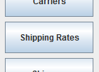Click on the Shipping Rates button on the left menu bar.
        2. 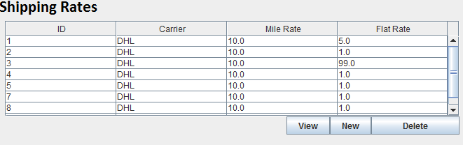The Shipping Rates table will then appear in the main area
        3. Find the Shipping Rate you wish to edit on the Shipping Rates table
        4. Select the desired Shipping Rate from the list
        5. Click on the View button
        6. 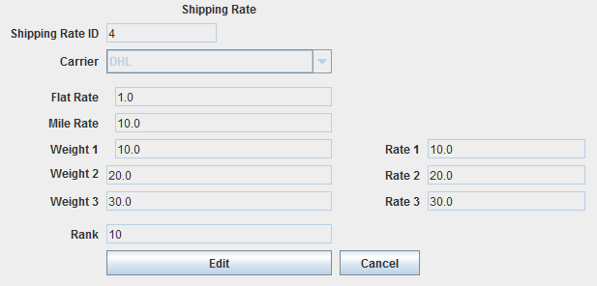The Shipping Rate Editor will appear below the Shipping Rate Table
        7. The selected Shipping Rate's information will populate the Shipping Rate Editor's fields.
        8. Click on the Edit Button in the Shipping Rate Editor
        9. The Shipping Rate's values will now become modifiable

**5.4.1 Changing the Shipping Rate's Carrier**

* + - * 1. Select a new Carrier from the Carrier dropbox.
        2. This dropbox will be populated with all the Carrier names in the database
        3. Click Save
        4. The new Carrier for this Shipping Rate will be updated in the database.

**5.4.2 Changing the Shipping Rate's Rates Categories**

**5.4.2.1 Changing the Shipping Rate's Rate 1**

Enter a new value for the Shipping Rate's Rate 1

Valid values must be greater than zero

If an invalid entry is made an error message will appear

Click Save

The new Rate 1 value will be updated in the database.

**5.4.2.2 Changing the Shipping Rate's Rate 2**

Enter a new value for the Shipping Rate's Rate 2

Valid values must be greater than zero

If an invalid entry is made an error message will appear

Click Save

The new Rate 2 value will be updated in the database.

**5.4.2.3 Changing the Shipping Rate's Rate 3**

Enter a new value for the Shipping Rate's Rate 3

Valid values must be greater than zero

If an invalid entry is made an error message will appear

Click Save

The new Rate 3 value will be updated in the database.

**5.4.2.4 Changing the Shipping Rate's Mile Rate**

Enter a new value for the Shipping Rate's Mile Rate



Valid values must be greater than zero

If an invalid entry is made an error message will appear

Click Save

The new Mile Rate value will be updated in the database.

**5.4.2.5 Changing the Shipping Rate's Flat Rate**

Enter a new value for the Shipping Rate's Flat Rate

Valid values must be greater than zero

If an invalid entry is made an error message will appear

Click Save

The new Flat Rate value will be updated in the database.

**5.4.3 Changing the Shipping Rate's Weight Categories**

**5.4.3.1 Changing the Shipping Rate's Weight 1**

Enter a new value for the Shipping Rate's Weight 1

Valid values must be greater than zero

If an invalid entry is made an error message will appear

Click Save

The new Weight 1 value will be updated in the database.

**5.4.3.2 Changing the Shipping Rate's Weight 2**

Enter a new value for the Shipping Rate's Weight 2

Valid values must be greater than zero

If an invalid entry is made an error message will appear

Click Save

The new Weight 2 value will be updated in the database.

**5.4.3.3 Changing the Shipping Rate's Weight 3**

Enter a new value for the Shipping Rate's Weight 3

Valid values must be greater than zero

If an invalid entry is made an error message will appear

Click Save

The new Weight 3 value will be updated in the database.

**5.4.4 Changing the Shipping Rate's Rank**

* + - * 1. Enter a new value for the Shipping Rate's Rank
        2. Valid values must be an integer between 0 and 10
        3. If an invalid entry is made an error message will appear
        4. Click Save
        5. The new Rank value will be updated in the database.

**5.5 Editing Carriers**

To edit an existing Carrier in the database follow these steps

1. 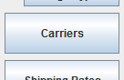Click on the Carriers button on the left menu bar.
2. The Carriers Table will appear in the main area
3. 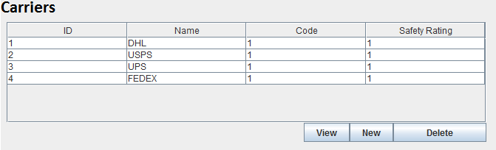Select the Carrier you wish to edit from the Table
4. Click on the View button
5. The Carrier Editor will appear below the Carrier Table
6. 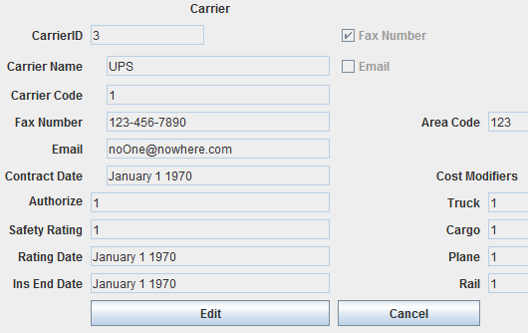The selected Carrier's information will populate the Carrier Editor's fields.
7. Click the Edit button on the Carrier Editor
8. This Carrier's values can now be modified.

**5.5.1 Changing A Carrier's Name**

* + - * 1. Enter a new name for the Carrier between 1 and 45 alphanumeric characters.
        2. If you enter an invalid name an error message will appear.
        3. Click Save
        4. The new name will be updated in the Carrier Table and in the database.

**5.5.2 Changing A Carrier's Code**

* + - * 1. Enter a new code for the Carrier between 1 and 4 alphanumeric characters.
        2. If you enter an invalid code an error message will appear.
        3. Click Save
        4. The new code will be updated in the Carrier Table and in the database.

**5.5.3 Changing A Carrier's Fax Number**

* + - * 1. Enter a new fax number for the Carrier using the following format, “###-###-####”
        2. If you enter an invalid number an error message will appear.
        3. Click Save
        4. The new number will be updated in the Carrier Table and in the database.

**5.5.4 Changing A Carrier's Email Address**

* + - * 1. Enter a new email address for the Carrier using the following format, “(any alphanumeric characters)@(any alphanumeric characters).(2-4 alphabetic characters)”
        2. If you enter an invalid email address an error message will appear.
        3. Click Save
        4. The new email address will be updated in the Carrier Table and in the database.

**5.5.5 Changing A Carrier's Contract Date**

* + - * 1. Enter a new Contract Date for the Carrier using the following format, “MM/dd/YYYY” ex 04/25/1990
        2. If you enter an invalid date an error message will appear.
        3. Click Save
        4. The new Contract Date will be updated in the Carrier Table and in the database.

**5.5.6 Changing A Carrier's Authorize Value**

* + - * 1. Enter a new Authorize value for the Carrier using an integer between 0 and 5.
        2. If you enter an invalid value an error message will appear.
        3. Click Save
        4. The new Authorize will be updated in the Carrier Table and in the database.

**5.5.7 Changing A Carrier's Safety Rating**

* + - * 1. Enter a new Safety Rating value for the Carrier using an integer between 0 and 100.
        2. If you enter an invalid value an error message will appear.
        3. Click Save
        4. The new Safety Rating will be updated in the Carrier Table and in the database.

**5.5.8 Changing A Carrier's Saftey Rating Date**

* + - * 1. Enter a new Safety Rating Date for the Carrier using the following format, “MM/dd/YYYY” ex 04/25/1990
        2. If you enter an invalid date an error message will appear.
        3. Click Save
        4. The new Safety Rating Date will be updated in the Carrier Table and in the database.

**5.5.9 Changing A Carrier's Ins End Date**

* + - * 1. Enter a new Ins End Date for the Carrier using the following format, “MM/dd/YYYY” ex 04/25/1990
        2. If you enter an invalid date an error message will appear.
        3. Click Save
        4. The new Ins End Date will be updated in the Carrier Table and in the database.

**5.5.10 Changing A Carrier's Cost Modifiers**

**5.5.10.1 Changing A Carrier's Truck Cost Modifier**

Enter a new Truck Cost Modifier value for the Carrier using an integer between 0 and 100.

If you enter an invalid value an error message will appear.

Click Save

The new Truck Cost Modifier will be updated in the Carrier Table and in the database.

**5.5.10.2 Changing A Carrier's Cargo Cost Modifier**

Enter a new Cargo Cost Modifier value for the Carrier using an integer between 0 and 100.

If you enter an invalid value an error message will appear.

Click Save

The new Cargo Cost Modifier will be updated in the Carrier Table and in the database.

**5.5.10.3 Changing A Carrier's Plane Cost Modifier**

Enter a new Plane Cost Modifier value for the Carrier using an integer between 0 and 100.

If you enter an invalid value an error message will appear.

Click Save

The new Plane Cost Modifier will be updated in the Carrier Table and in the database.

**5.5.10.4 Changing A Carrier's Rail Cost Modifier**

Enter a new Rail Cost Modifier value for the Carrier using an integer between 0 and 100.

If you enter an invalid value an error message will appear.

Click Save

The new Rail Cost Modifier will be updated in the Carrier Table and in the database.

**5.6 Editing Shipments**

To edit an existing Shipment in the database follow these steps

1. 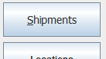Click on the Shipments button on the left menu bar.
2. The Shipments Table will appear in the main area
3. 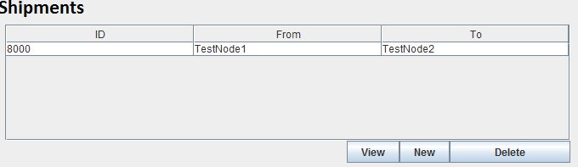Select the Shipment you wish to edit from the Table
4. Click on the View button
5. 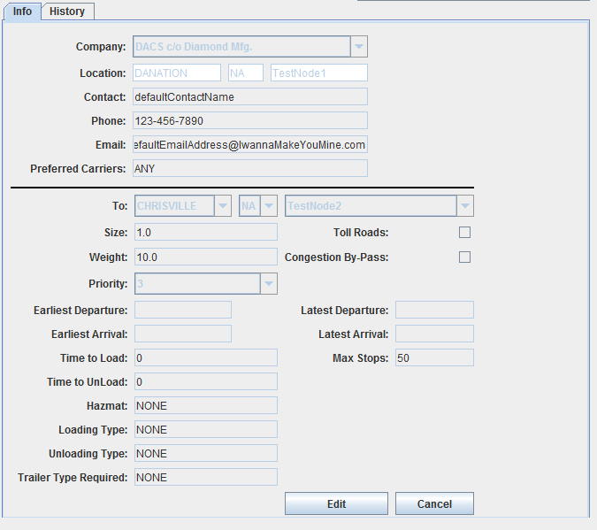The Shipment Editor will appear below the Shipment Table
6. The selected Shipment's information will populate the Shipment Editor's fields.
7. Click the Edit button on the Shipment Editor
8. This Shipment's values can now be modified.

**5.6.1 Changing a Shipment's Start Location**

* + - * 1. A Shipment's Start Location is dictated by its Shipper.
        2. The change the Start Location please select a new Shipper
        3. You can see how to set a Shipment's Shipper in Section 5.6.12

**5.6.2 Changing a Shipment's End Location**

* + - * 1. Change the Country dropbox next to the 'To:' label to the desired country
        2. This change will update the States and City dropboxes
        3. Select the desired State for the new End Location from the State dropbox
        4. This change will update the City dropbox
        5. Finally select the desired City for the new End Location from the City dropbox.
        6. Click Save
        7. The new End Location for the Shipment will be save to the database.

**5.6.3 Changing a Shipment's Priority**

* + - * 1. Select a new Priority for the Shipment using the Priority drop box.
        2. The range of possible values are 1 -10 with 10 being the most important
        3. Click Save
        4. The new Priority for the Shipment will be saved to the database

**5.6.4 Changing a Shipment's Weight**

* + - * 1. Enter a new Weight for the Shipment in the Weight field.
        2. The new weight must be greater than 0.
        3. Click Save
        4. The new Weight for the Shipment will be saved to the database

**5.6.5 Changing a Shipment's Size**

* + - * 1. Enter a new Size for the Shipment in the Size field.
        2. The new Size must be greater than 0.
        3. Click Save
        4. The new Size for the Shipment will be saved to the database

**5.6.6 Changing a Shipment's Earliest Arrival Time-Currently Not Supported**

* + - * 1. Enter a new Earliest Arrival Time for the Shipment using the following format, “HH:mm MM/dd/YYYY” ex 15:30 04/25/1990
        2. If you enter an invalid date an error message will appear.
        3. Click Save
        4. The new Earliest Arrival Time will be updated in the Shipment Table and in the database.

**5.6.7 Changing a Shipment's Latest Arrival Time-Currently Not Supported**

* + - * 1. Enter a new Latest Arrival Time for the Shipment using the following format, “HH:mm MM/dd/YYYY” ex 15:30 04/25/1990
        2. If you enter an invalid date an error message will appear.
        3. Click Save
        4. The new Latest Arrival Time will be updated in the Shipment Table and in the database.

**5.6.8 Changing a Shipment's Earliest Departure Time-Currently Not Supported**

* + - * 1. Enter a new Earliest Departure Time for the Shipment using the following format, “HH:mm MM/dd/YYYY” ex 15:30 04/25/1990
        2. If you enter an invalid date an error message will appear.
        3. Click Save
        4. The new Earliest Departure Time will be updated in the Shipment Table and in the database.

**5.6.9 Changing a Shipment's Latest Departure Time-Currently Not Supported**

* + - * 1. Enter a new Latest Departure Time for the Shipment using the following format, “HH:mm MM/dd/YYYY” ex 15:30 04/25/1990
        2. If you enter an invalid date an error message will appear.
        3. Click Save
        4. The new Latest Departure Time will be updated in the Shipment Table and in the database.

**5.6.10 Changing a Shipment's Time To Load-Currently Not Supported**

* + - * 1. Enter a new Time to Load for the Shipment in the Time to Load field.
        2. The new Time to Load must be greater than or equal to 0.
        3. Click Save
        4. The new Time to Load for the Shipment will be saved to the database

**5.6.11 Changing a Shipment's Time To Unload-Currently Not Supported**

* + - * 1. Enter a new Time to Unload for the Shipment in the Time to Unload field.
        2. The new Time to Unload must be greater than or equal to 0.
        3. Click Save
        4. The new Time to Unload for the Shipment will be saved to the database

**5.6.12 Changing a Shipment's Shipper**

* + - * 1. Use the Shipper dropbox to select a new Shipper
        2. This change will update the Start Location of the Shipment to the Location of the Shipper as well.
        3. Click Save
        4. 
        5. The new Shipper for the Shipment will be saved to the database.

**5.6.13 Changing a Shipment's Toll Road Option-Currently Not Supported**

* + - * 1. Check the Toll Road checkbox to allow the Shipment to take Toll Roads
        2. Uncheck the Toll Road checkbox to not allow the Shipment to take Toll Roads
        3. Click Save
        4. The new state of the checkbox will be save to the database.

**5.6.14 Changing a Shipment`s Congestion Bypass Option-Currently Not Supported**

* + - * 1. Check the Congestion Bypass checkbox to allow the Shipment to perform Congestion Bypasses.
        2. Uncheck the Congestion Bypass checkbox to not allow the Shipment to perform Congestion Bypasses.
        3. Click Save
        4. The new state of the checkbox will be save to the database.

**5.6.15 Changing a Shipment's Maximum Stops**

* + - * 1. Enter a new maximum number of stops for the Shipment in the maximum stops field.
        2. The new maximum number of stops must be greater than 0.
        3. Click Save
        4. The new maximum number of stops for the Shipment will be saved to the database

**5.6.16 Changing a Shipment's Hazardous Material Constraints-Currently Not Supported**

* + - * 1. Enter a new string between 1 and 45 alphabetical characters to specify the Hazardous Material constraints for this Shipment.
        2. If an invalid entry is made an error message will appear.
        3. Click Save
        4. The new Hazardous Material Constraints will be saved to the database.

**5.6.17 Changing a Shipment's Loading Rate-Currently Not Supported**

* + - * 1. Enter a new Loading Rate for the Shipment in the Loading Rate field.
        2. The new Loading Rate must be greater than or equal to 0.
        3. Click Save
        4. 
        5. The new Loading Rate for the Shipment will be saved to the database

**5.6.18 Changing a Shipment's Trailer Type-Currently Not Supported**

* + - * 1. Enter a new string between 1 and 45 alphabetical characters to specify the Trailer Type for this Shipment.
        2. If an invalid entry is made an error message will appear.
        3. Click Save
        4. The new Trailer Type will be saved to the database.

**5.6.19 Changing a Shipment's Loading Type-Currently Not Supported**

* + - * 1. Enter a new string between 1 and 45 alphabetical characters to specify the Loading Type for this Shipment.
        2. If an invalid entry is made an error message will appear.
        3. Click Save
        4. The new Loading Type will be saved to the database.

**5.6.20 Changing a Shipment's Unloading Type-Currently Not Supported**

* + - * 1. Enter a new string between 1 and 45 alphabetical characters to specify the Unloading Type for this Shipment.
        2. If an invalid entry is made an error message will appear.
        3. Click Save
        4. The new Unloading Type will be saved to the database.

**5.7 Editing Shippers**

To edit an existing Shipper in the database follow these steps

1. Click on the Shippers button on the left menu bar.
2. 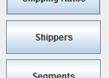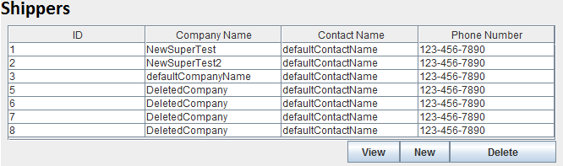The Shippers Table will appear in the main area
3. Select the Shipper you wish to edit from the Table
4. Click on the View button
5. 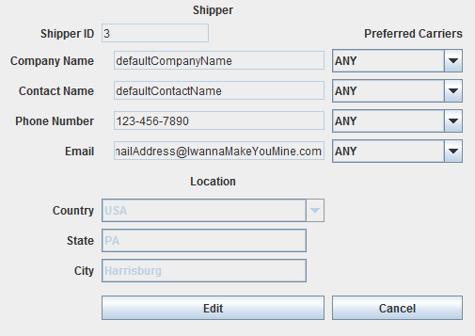The Shipper Editor will appear below the Shipper Table
6. The selected Shipper's information will populate the Shipper Editor's fields.
7. Click the Edit button on the Shipper Editor
8. The Shippers values are now modifiable

**5.7.1 Changing a Shipper's Location**

* + - * 1. Select a new Country for the Shipper from the Country dropbox
        2. This selection will cause the State and City dropboxes to update
        3. Select the new State for the Shipper from the State dropbox
        4. This selection will cause the City dropbox to update
        5. Select the new City for the Shipper
        6. Click Save
        7. The new Location will be saved to the database.

**5.7.2 Changing a Shipper's Preferred Carriers-Currently Not Supported**

* + - * 1. Select a new Preferred Carrier from the dropboxes.
        2. 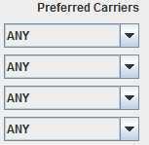Note that duplicates will be ignored.
        3. Click Save
        4. The new Preferred Carriers will be saved to the database.

**5.7.3 Changing a Shipper's Company Name**

* + - * 1. Enter a new Company Name between 1 and 45 alphabetical characters to specify the Company Name for this Shipper.
        2. If an invalid entry is made an error message will appear.
        3. Click Save
        4. The new Company Name will be saved to the database.

**5.7.4 Changing a Shipper's Contact Name**

* + - * 1. Enter a new Contact Name between 1 and 45 alphabetical characters to specify the Contact Name for this Shipper.
        2. If an invalid entry is made an error message will appear.
        3. Click Save
        4. The new Contact Name will be saved to the database.

**5.7.5 Changing a Shipper's Phone Number**

* + - * 1. Enter a new phone number for the Shipper using the following format, “###-###-####”
        2. If you enter an invalid number an error message will appear.
        3. Click Save
        4. The new phone number will be updated in the Shipper Table and in the database.

**5.7.6 Changing a Shipper's Email Address**

* + - * 1. Enter a new email address for the Shipper using the following format, “(any alphanumeric characters)@(any alphanumeric characters).(2-4 alphabetic characters)”
        2. If you enter an invalid email address an error message will appear.
        3. Click Save
        4. The new email address will be updated in the Shipper Table and in the database.

**5.8 Editing Travel Types**

**5.8.1 Editing Truck Types**

To edit an existing Truck Type in the database follow these steps

1. Click on the Truck Types button on the left menu bar.
2. 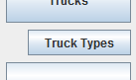The Truck Types Table will appear in the main area
3. 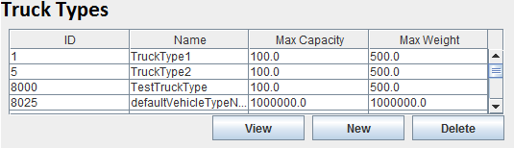Select the Truck Type you wish to edit from the Table
4. Click on the View button
5. 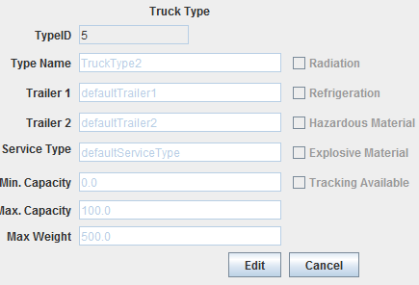The Truck Type Editor will appear below the Truck Type Table
6. The selected Truck Type's information will populate the Truck Type Editor's fields.
7. Click the Edit button on the Truck Type Editor
8. This Truck Type's values can now be modified.

**5.8.1.1 Changing a Truck Type's Name**

* + - * 1. Enter a new Name between 1 and 45 alphabetical characters to specify the Name for this Truck Type.
        2. If an invalid entry is made an error message will appear.
        3. Click Save
        4. The new Name will be saved to the database.

**5.8.1.2 Changing a Truck Type's Trailer 1-Currently Not Supported**

* + - * 1. Enter a new Trailer 1 between 1 and 45 alphabetical characters to specify the Trailer 1 for this Truck Type.
        2. If an invalid entry is made an error message will appear.
        3. Click Save
        4. The new Trailer 1 will be saved to the database.

**5.8.1.3 Changing a Truck Type's Trailer 2-Currently Not Supported**

* + - * 1. Enter a new Trailer 2 between 1 and 45 alphabetical characters to specify the Trailer 2 for this Truck Type.
        2. If an invalid entry is made an error message will appear.
        3. Click Save
        4. The new Trailer 2 will be saved to the database.

**5.8.1.4 Changing a Truck Type's Service Type-Currently Not Supported**

* + - * 1. Enter a new Service Type between 1 and 45 alphabetical characters to specify the Service Type for this Truck Type.
        2. If an invalid entry is made an error message will appear.
        3. Click Save
        4. The new Service Type will be saved to the database.

**5.8.1.5 Changing a Truck Type's Minimum Capacity**

* + - * 1. Enter a new Minimum Capacity for the Truck Type.
        2. The new Minimum Capacity must be greater than or equal to 0.
        3. Click Save
        4. The new Minimum Capacity for the Shipment will be saved to the database

**5.8.1.6 Changing a Truck Type's Maximum Capacity**

* + - * 1. Enter a new Maximum Capacity for the Truck Type.
        2. The new Maximum Capacity must be greater than or equal to 0.
        3. Click Save
        4. The new Maximum Capacity for the Shipment will be saved to the database

**5.8.1.7 Changing a Truck Type's Maximum Weight**

* + - * 1. Enter a new Maximum Weight for the Truck Type.
        2. The new Maximum Weight must be greater than or equal to 0.
        3. Click Save
        4. The new Maximum Weight for the Shipment will be saved to the database

**5.8.1.8 Changing a Truck Type's Radiation Option-Currently Not Supported**

* + - * 1. Check the Radiation checkbox if this Truck Type can handle radioactive Shipments.
        2. Uncheck the Radiation checkbox if this Truck Type can not handle radioactive Shipments.
        3. Click Save
        4. The new state of the Radiation checkbox will be saved to the database.

**5.8.1.9 Changing a Truck Type's Refrigeration Option-Currently Not Supported**

* + - * 1. Check the Refrigeration checkbox if this Truck Type can handle refrigerated Shipments.
        2. Uncheck the Refrigeration checkbox if this Truck Type can not handle refrigerated Shipments.
        3. Click Save
        4. The new state of the Refrigeration checkbox will be saved to the database.

**5.8.1.10 Changing a Truck Type's Hazardous Material Option-Currently Not Supported**

* + - * 1. Check the Hazardous Material checkbox if this Truck Type can handle hazardous Shipments.
        2. Uncheck the Hazardous Material checkbox if this Truck Type can not handle hazardous Shipments.
        3. Click Save
        4. The new state of the Hazardous Material checkbox will be saved to the database.

**5.8.1.11 Changing a Truck Type's Explosive Material Option-Currently Not Supported**

* + - * 1. Check the Explosive Material checkbox if this Truck Type can handle explosive Shipments.
        2. Uncheck the Explosive Material checkbox if this Truck Type can not handle explosive Shipments.
        3. Click Save
        4. The new state of the Explosive Material checkbox will be saved to the database.

**5.8.1.12 Changing a Truck Type's Tracking Available Option-Currently Not Supported**

* + - * 1. Check the Tracking Available checkbox if this Truck Type has tracking available.
        2. Uncheck the Tracking Available checkbox if this Truck Type does not have tracking available.
        3. Click Save
        4. The new state of the Tracking Available checkbox will be saved to the database.

**5.8.2 Editing Cargo Types**

To edit an existing Cargo Type in the database follow these steps

1. 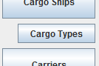Click on the Cargo Types button on the left menu bar.
2. 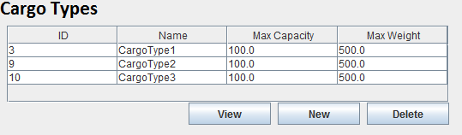The Cargo Types Table will appear in the main area
3. Select the Cargo Type you wish to edit from the Table
4. Click on the View button
5. 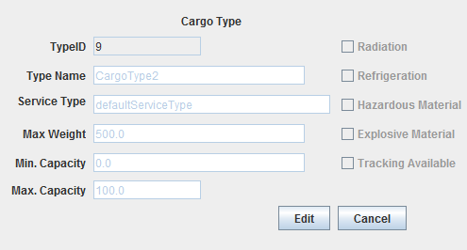The Cargo Type Editor will appear below the Cargo Type Table
6. The selected Cargo Type's information will populate the Cargo Type Editor's fields.
7. Click the Edit button on the Cargo Type Editor
8. This Cargo Type's values can now be modified.

**5.8.2.1 Changing a Cargo Type's Name**

* + - * 1. Enter a new Name between 1 and 45 alphabetical characters to specify the Name for this Cargo Type.
        2. If an invalid entry is made an error message will appear.
        3. Click Save
        4. The new Name will be saved to the database.

**5.8.2.2 Changing a Cargo Type's Trailer 1-Currently Not Supported**

* + - * 1. Enter a new Trailer 1 between 1 and 45 alphabetical characters to specify the Trailer 1 for this Cargo Type.
        2. If an invalid entry is made an error message will appear.
        3. Click Save
        4. The new Trailer 1 will be saved to the database.

**5.8.2.3 Changing a Cargo Type's Trailer 2-Currently Not Supported**

* + - * 1. Enter a new Trailer 2 between 1 and 45 alphabetical characters to specify the Trailer 2 for this Cargo Type.
        2. If an invalid entry is made an error message will appear.
        3. Click Save
        4. The new Trailer 2 will be saved to the database.

**5.8.2.4 Changing a Cargo Type's Service Type-Currently Not Supported**

* + - * 1. Enter a new Service Type between 1 and 45 alphabetical characters to specify the Service Type for this Cargo Type.
        2. If an invalid entry is made an error message will appear.
        3. Click Save
        4. The new Service Type will be saved to the database.

**5.8.2.5 Changing a Cargo Type's Minimum Capacity**

* + - * 1. Enter a new Minimum Capacity for the Cargo Type.
        2. The new Minimum Capacity must be greater than or equal to 0.
        3. Click Save
        4. The new Minimum Capacity for the Shipment will be saved to the database

**5.8.2.6 Changing a Cargo Type's Maximum Capacity**

* + - * 1. Enter a new Maximum Capacity for the Cargo Type.
        2. The new Maximum Capacity must be greater than or equal to 0.
        3. Click Save
        4. The new Maximum Capacity for the Shipment will be saved to the database

**5.8.2.7 Changing a Cargo Type's Maximum Weight**

* + - * 1. Enter a new Maximum Weight for the Cargo Type.
        2. The new Maximum Weight must be greater than or equal to 0.
        3. Click Save
        4. The new Maximum Weight for the Shipment will be saved to the database

**5.8.2.8 Changing a Cargo Type's Radiation Option-Currently Not Supported**

* + - * 1. Check the Radiation checkbox if this Cargo Type can handle radioactive Shipments.
        2. Uncheck the Radiation checkbox if this Cargo Type can not handle radioactive Shipments.
        3. Click Save
        4. The new state of the Radiation checkbox will be saved to the database.

**5.8.2.9 Changing a Cargo Type's Refrigeration Option-Currently Not Supported**

* + - * 1. Check the Refrigeration checkbox if this Cargo Type can handle refrigerated Shipments.
        2. Uncheck the Refrigeration checkbox if this Cargo Type can not handle refrigerated Shipments.
        3. Click Save
        4. The new state of the Refrigeration checkbox will be saved to the database.

**5.8.2.10 Changing a Cargo Type's Hazardous Material Option-Currently Not Supported**

* + - * 1. Check the Hazardous Material checkbox if this Cargo Type can handle hazardous Shipments.
        2. Uncheck the Hazardous Material checkbox if this Cargo Type can not handle hazardous Shipments.
        3. Click Save
        4. The new state of the Hazardous Material checkbox will be saved to the database.

**5.8.2.11 Changing a Cargo Type's Explosive Material Option-Currently Not Supported**

* + - * 1. Check the Explosive Material checkbox if this Cargo Type can handle explosive Shipments.
        2. Uncheck the Explosive Material checkbox if this Cargo Type can not handle explosive Shipments.
        3. Click Save
        4. The new state of the Explosive Material checkbox will be saved to the database.

**5.8.2.12 Changing a Cargo Type's Tracking Available Option-Currently Not Supported**

* + - * 1. Check the Tracking Available checkbox if this Cargo Type has tracking available.
        2. Uncheck the Tracking Available checkbox if this Cargo Type does not have tracking available.
        3. Click Save
        4. The new state of the Tracking Available checkbox will be saved to the database.

**5.8.3 Editing Plane Types**

To edit an existing Plane Type in the database follow these steps

1. 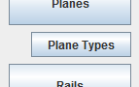Click on the Plane Types button on the left menu bar.
2. 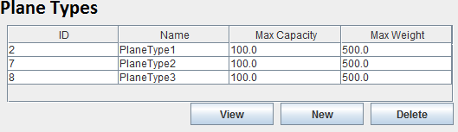The Plane Types Table will appear in the main area
3. Select the Plane Type you wish to edit from the Table
4. Click on the View button
5. The Plane Type Editor will appear below the Plane Type Table
6. 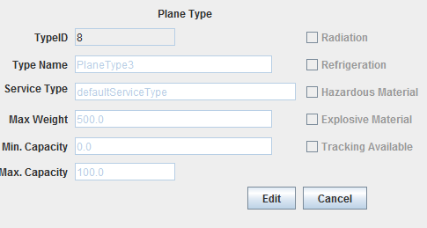The selected Plane Type's information will populate the Plane Type Editor's fields.
7. Click the Edit button on the Plane Type Editor
8. This Plane Type's values can now be modified.

**5.8.3.1 Changing a Plane Type's Name**

* + - * 1. Enter a new Name between 1 and 45 alphabetical characters to specify the Name for this Plane Type.
        2. If an invalid entry is made an error message will appear.
        3. Click Save
        4. The new Name will be saved to the database.

**5.8.3.2 Changing a Plane Type's Trailer 1-Currently Not Supported**

* + - * 1. Enter a new Trailer 1 between 1 and 45 alphabetical characters to specify the Trailer 1 for this Plane Type.
        2. If an invalid entry is made an error message will appear.
        3. Click Save
        4. The new Trailer 1 will be saved to the database.

**5.8.3.3 Changing a Plane Type's Trailer 2-Currently Not Supported**

* + - * 1. Enter a new Trailer 2 between 1 and 45 alphabetical characters to specify the Trailer 2 for this Plane Type.
        2. If an invalid entry is made an error message will appear.
        3. Click Save
        4. The new Trailer 2 will be saved to the database.

**5.8.3.4 Changing a Plane Type's Service Type-Currently Not Supported**

* + - * 1. Enter a new Service Type between 1 and 45 alphabetical characters to specify the Service Type for this Plane Type.
        2. If an invalid entry is made an error message will appear.
        3. Click Save
        4. The new Service Type will be saved to the database.

**5.8.3.5 Changing a Plane Type's Minimum Capacity**

* + - * 1. Enter a new Minimum Capacity for the Plane Type.
        2. The new Minimum Capacity must be greater than or equal to 0.
        3. Click Save
        4. The new Minimum Capacity for the Shipment will be saved to the database

**5.8.3.6 Changing a Plane Type's Maximum Capacity**

* + - * 1. Enter a new Maximum Capacity for the Plane Type.
        2. The new Maximum Capacity must be greater than or equal to 0.
        3. Click Save
        4. The new Maximum Capacity for the Shipment will be saved to the database

**5.8.3.7 Changing a Plane Type's Maximum Weight**

* + - * 1. Enter a new Maximum Weight for the Plane Type.
        2. The new Maximum Weight must be greater than or equal to 0.
        3. Click Save
        4. The new Maximum Weight for the Shipment will be saved to the database

**5.8.3.8 Changing a Plane Type's Radiation Option-Currently Not Supported**

* + - * 1. Check the Radiation checkbox if this Plane Type can handle radioactive Shipments.
        2. Uncheck the Radiation checkbox if this Plane Type can not handle radioactive Shipments.
        3. Click Save
        4. The new state of the Radiation checkbox will be saved to the database.

**5.8.3.9 Changing a Plane Type's Refrigeration Option-Currently Not Supported**

* + - * 1. Check the Refrigeration checkbox if this Plane Type can handle refrigerated Shipments.
        2. Uncheck the Refrigeration checkbox if this Plane Type can not handle refrigerated Shipments.
        3. Click Save
        4. The new state of the Refrigeration checkbox will be saved to the database.

**5.8.3.10 Changing a Plane Type's Hazardous Material Option-Currently Not Supported**

* + - * 1. Check the Hazardous Material checkbox if this Plane Type can handle hazardous Shipments.
        2. Uncheck the Hazardous Material checkbox if this Plane Type can not handle hazardous Shipments.
        3. Click Save
        4. The new state of the Hazardous Material checkbox will be saved to the database.

**5.8.3.11 Changing a Plane Type's Explosive Material Option-Currently Not Supported**

* + - * 1. Check the Explosive Material checkbox if this Plane Type can handle explosive Shipments.
        2. Uncheck the Explosive Material checkbox if this Plane Type can not handle explosive Shipments.
        3. Click Save
        4. The new state of the Explosive Material checkbox will be saved to the database.

**5.8.3.12 Changing a Plane Type's Tracking Available Option-Currently Not Supported**

* + - * 1. Check the Tracking Available checkbox if this Plane Type has tracking available.
        2. Uncheck the Tracking Available checkbox if this Plane Type does not have tracking available.
        3. Click Save
        4. The new state of the Tracking Available checkbox will be saved to the database.

**5.8.4 Editing Rail Types**

To edit an existing Rail Type in the database follow these steps

1. 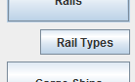Click on the Rail Types button on the left menu bar.
2. The Rail Types Table will appear in the main area
3. 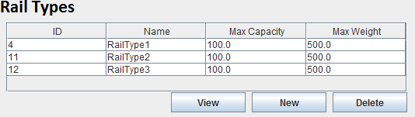Select the Rail Type you wish to edit from the Table
4. Click on the View button
5. The Rail Type Editor will appear below the Rail Type Table
6. 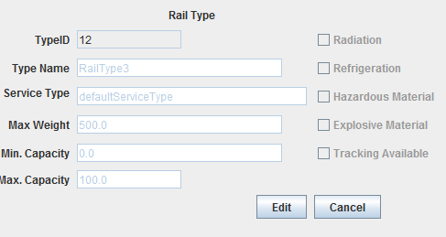The selected Rail Type's information will populate the Rail Type Editor's fields.
7. Click the Edit button on the Rail Type Editor
8. This Rail Type's values can now be modified.

**5.8.4.1 Changing a Rail Type's Name**

* + - * 1. Enter a new Name between 1 and 45 alphabetical characters to specify the Name for this Rail Type.
        2. If an invalid entry is made an error message will appear.
        3. Click Save
        4. The new Name will be saved to the database.

**5.8.4.2 Changing a Rail Type's Trailer 1-Currently Not Supported**

* + - * 1. Enter a new Trailer 1 between 1 and 45 alphabetical characters to specify the Trailer 1 for this Rail Type.
        2. If an invalid entry is made an error message will appear.
        3. Click Save
        4. The new Trailer 1 will be saved to the database.

**5.8.4.3 Changing a Rail Type's Trailer 2-Currently Not Supported**

* + - * 1. Enter a new Trailer 2 between 1 and 45 alphabetical characters to specify the Trailer 2 for this Rail Type.
        2. If an invalid entry is made an error message will appear.
        3. Click Save
        4. The new Trailer 2 will be saved to the database.

**5.8.4.4 Changing a Rail Type's Service Type-Currently Not Supported**

* + - * 1. Enter a new Service Type between 1 and 45 alphabetical characters to specify the Service Type for this Rail Type.
        2. If an invalid entry is made an error message will appear.
        3. Click Save
        4. The new Service Type will be saved to the database.

**5.8.4.5 Changing a Rail Type's Minimum Capacity**

* + - * 1. Enter a new Minimum Capacity for the Rail Type.
        2. The new Minimum Capacity must be greater than or equal to 0.
        3. Click Save
        4. The new Minimum Capacity for the Shipment will be saved to the database

**5.8.4.6 Changing a Rail Type's Maximum Capacity**

* + - * 1. Enter a new Maximum Capacity for the Rail Type.
        2. The new Maximum Capacity must be greater than or equal to 0.
        3. Click Save
        4. The new Maximum Capacity for the Shipment will be saved to the database

**5.8.4.7 Changing a Rail Type's Maximum Weight**

* + - * 1. Enter a new Maximum Weight for the Rail Type.
        2. The new Maximum Weight must be greater than or equal to 0.
        3. Click Save
        4. The new Maximum Weight for the Shipment will be saved to the database

**5.8.4.8 Changing a Rail Type's Radiation Option-Currently Not Supported**

* + - * 1. Check the Radiation checkbox if this Rail Type can handle radioactive Shipments.
        2. Uncheck the Radiation checkbox if this Rail Type can not handle radioactive Shipments.
        3. Click Save
        4. The new state of the Radiation checkbox will be saved to the database.

**5.8.4.9 Changing a Rail Type's Refrigeration Option-Currently Not Supported**

* + - * 1. Check the Refrigeration checkbox if this Rail Type can handle refrigerated Shipments.
        2. Uncheck the Refrigeration checkbox if this Rail Type can not handle refrigerated Shipments.
        3. Click Save
        4. The new state of the Refrigeration checkbox will be saved to the database.

**5.8.4.10 Changing a Rail Type's Hazardous Material Option-Currently Not Supported**

* + - * 1. Check the Hazardous Material checkbox if this Rail Type can handle hazardous Shipments.
        2. Uncheck the Hazardous Material checkbox if this Rail Type can not handle hazardous Shipments.
        3. Click Save
        4. The new state of the Hazardous Material checkbox will be saved to the database.

**5.8.4.11 Changing a Rail Type's Explosive Material Option-Currently Not Supported**

* + - * 1. Check the Explosive Material checkbox if this Rail Type can handle explosive Shipments.
        2. Uncheck the Explosive Material checkbox if this Rail Type can not handle explosive Shipments.
        3. Click Save
        4. The new state of the Explosive Material checkbox will be saved to the database.

**5.8.4.12 Changing a Rail Type's Tracking Available Option-Currently Not Supported**

* + - * 1. Check the Tracking Available checkbox if this Rail Type has tracking available.
        2. Uncheck the Tracking Available checkbox if this Rail Type does not have tracking available.
        3. Click Save
        4. The new state of the Tracking Available checkbox will be saved to the database.

**6. Removing Objects From The Database**

The MMRP Database can have objects removed from the database. This will stop outdated and unneeded objects from altering the routing procedures. To remove an item from the database follow the steps listed below.

**6.1 Removing Vehicles**

**6.1.1 Removing Trucks**

To remove a Truck from the database follow these steps

* + - * 1. Click on the Trucks button the menu bar on the left
        2. 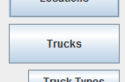The Trucks table will appear in the main area
        3. 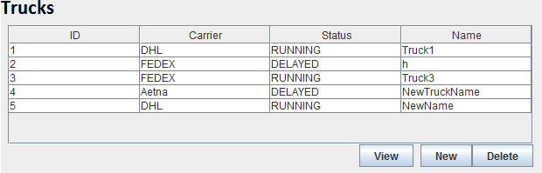Select the Truck you wish to remove from the database
        4. Click Delete
        5. You will be prompted with a message box with the following warning, “Recovery of this object may not be possible after deletion, are you sure you wish to delete this Truck?”
        6. Click Ok
        7. The selected Truck will be marked as deleted in the database and will not be used in future routing.

**6.1.2 Removing Cargo Ships**

To remove a Cargo Ship from the database follow these steps

* + - * 1. Click on the Cargo Ships button the menu bar on the left

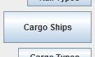

* + - * 1. The Cargo Ships table will appear in the main area

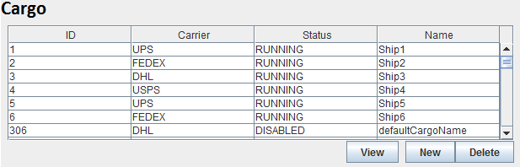

* + - * 1. Select the Cargo Ship you wish to remove from the database



* + - * 1. Click Delete



* + - * 1. You will be prompted with a message box with the following warning, “Recovery of this object may not be possible after deletion, are you sure you wish to delete this Cargo Ship?”
        2. Click Ok
        3. The selected Cargo Ship will be marked as deleted in the database and will not be used in future routing.

**6.1.3 Removing Planes**

To remove a Plane from the database follow these steps

* + - * 1. 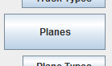Click on the Planes button the menu bar on the left
        2. The Planes table will appear in the main area

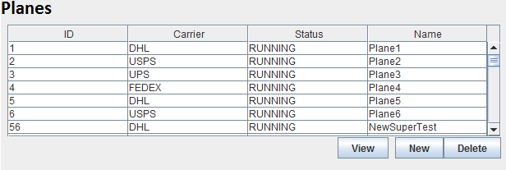

* + - * 1. Select the Plane you wish to remove from the database



* + - * 1. Click Delete



* + - * 1. You will be prompted with a message box with the following warning, “Recovery of this object may not be possible after deletion, are you sure you wish to delete this Plane?”
        2. Click Ok
        3. The selected Plane will be marked as deleted in the database and will not be used in future routing.

**6.1.4 Removing Rails**

To remove a Rail from the database follow these steps

* + - * 1. Click on the Rails button the menu bar on the left

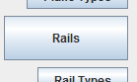

* + - * 1. The Rails table will appear in the main area

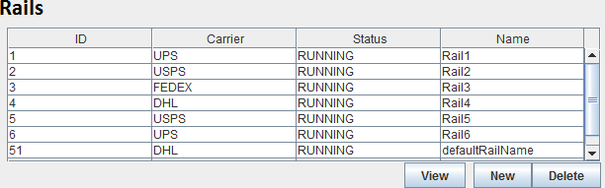

* + - * 1. Select the Rail you wish to remove from the database



* + - * 1. Click Delete



* + - * 1. You will be prompted with a message box with the following warning, “Recovery of this object may not be possible after deletion, are you sure you wish to delete this Rail?”
        2. Click Ok
        3. The selected Rail will be marked as deleted in the database and will not be used in future routing.

**6.2 Removing Locations**

To remove a Location from the database follow these steps

* + - * 1. Click on the Locations button the menu bar on the left

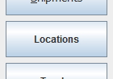

* + - * 1. The Locations table will appear in the main area

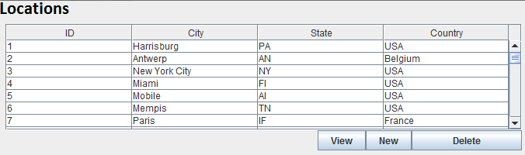

* + - * 1. Select the Location you wish to remove from the database



* + - * 1. Click Delete



* + - * 1. You will be prompted with a message box with the following warning, “Recovery of this object may not be possible after deletion, are you sure you wish to delete this Location?”
        2. Click Ok
        3. The selected Location will be marked as deleted in the database and will not be used in future routing.

**6.3 Removing Segments**

To remove a Segment from the database follow these steps

* + - * 1. 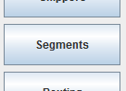Click on the Segments button the menu bar on the left
        2. The Segments table will appear in the main area

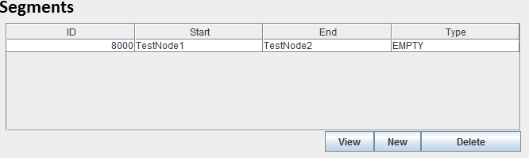

* + - * 1. Select the Segment you wish to remove from the database



* + - * 1. Click Delete



* + - * 1. You will be prompted with a message box with the following warning, “Recovery of this object may not be possible after deletion, are you sure you wish to delete this Segment?”
        2. Click Ok
        3. The selected Segment will be marked as deleted in the database and will not be used in future routing.

**6.4 Removing Shipping Rates**

To remove a Shipping Rate from the database follow these steps

* + - * 1. Click on the Shipping Rate button the menu bar on the left

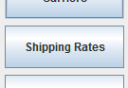

* + - * 1. The Shipping Rates table will appear in the main area

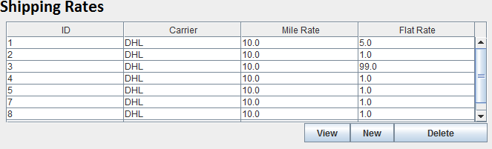

* + - * 1. Select the Shipping Rate you wish to remove from the database



* + - * 1. Click Delete



* + - * 1. You will be prompted with a message box with the following warning, “Recovery of this object may not be possible after deletion, are you sure you wish to delete this Shipping Rate?”
        2. Click Ok
        3. The selected Shipping Rate will be marked as deleted in the database and will not be used in future routing.

**6.5 Removing Carriers**

To remove a Carrier from the database follow these steps

1. Click on the Carrier button the menu bar on the left

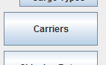

1. The Carriers table will appear in the main area

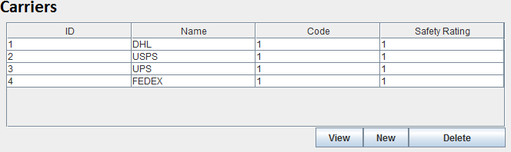

1. Select the Carrier you wish to remove from the database



1. Click Delete



1. You will be prompted with a message box with the following warning, “Recovery of this object may not be possible after deletion, are you sure you wish to delete this Carrier?”
2. Click Ok
3. The selected Carrier will be marked as deleted in the database and will not be used in future routing.

**6.6 Removing Shipments**

To remove a Shipment from the database follow these steps

1. Click on the Shipment button the menu bar on the left

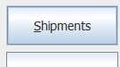

1. The Shipments table will appear in the main area

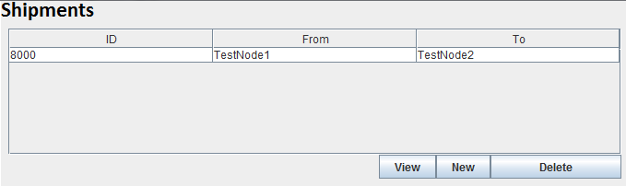

1. Select the Shipment you wish to remove from the database



1. Click Delete



1. You will be prompted with a message box with the following warning, “Recovery of this object may not be possible after deletion, are you sure you wish to delete this Shipment?”
2. Click Ok
3. The selected Shipment will be marked as deleted in the database and will not be used in future routing.

**6.7 Removing Shippers**

To remove a Shipper from the database follow these steps

1. Click on the Shippers button the menu bar on the left

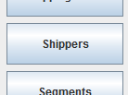

1. The Shippers table will appear in the main area

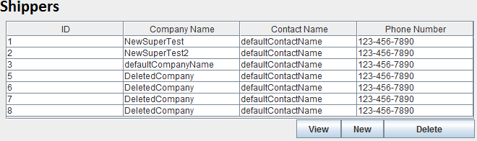

1. Select the Shipper you wish to remove from the database



1. Click Delete



1. You will be prompted with a message box with the following warning, “Recovery of this object may not be possible after deletion, are you sure you wish to delete this Shipper?”
2. Click Ok
3. The selected Shipper will be marked as deleted in the database and will not be used in future routing.

**6.8 Removing Travel Types**

**6.8.1 Removing Truck Types**

To remove a Truck Type from the database follow these steps

1. Click on the Truck Types button the menu bar on the left

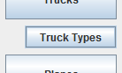

1. The Truck Types table will appear in the main area

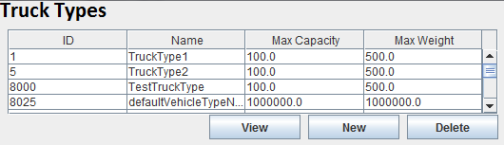

1. Select the Truck Type you wish to remove from the database



1. Click Delete



1. You will be prompted with a message box with the following warning, “Recovery of this object may not be possible after deletion, are you sure you wish to delete this Truck Type?”
2. Click Ok
3. The selected Truck Type will be marked as deleted in the database and will not be used in future routing.

**6.8.2 Removing Cargo Types**

To remove a Cargo Type from the database follow these steps

1. Click on the Cargo Types button the menu bar on the left

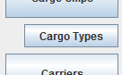

1. The Cargo Types table will appear in the main area

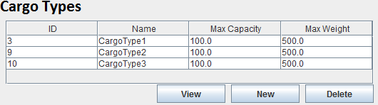

1. Select the Cargo Type you wish to remove from the database



1. Click Delete



1. You will be prompted with a message box with the following warning, “Recovery of this object may not be possible after deletion, are you sure you wish to delete this Cargo Type?”
2. Click Ok
3. The selected Cargo Type will be marked as deleted in the database and will not be used in future routing.

**6.8.3 Removing Plane Types**

To remove a Plane Type from the database follow these steps

1. Click on the Plane Types button the menu bar on the left

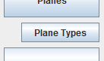

1. The Plane Types table will appear in the main area

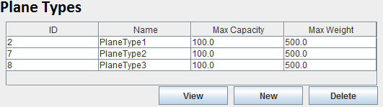

1. Select the Plane Type you wish to remove from the database



1. Click Delete



1. You will be prompted with a message box with the following warning, “Recovery of this object may not be possible after deletion, are you sure you wish to delete this Plane Type?”
2. Click Ok
3. The selected Plane Type will be marked as deleted in the database and will not be used in future routing.

**6.8.4 Removing Rail Types**

To remove a Rail Type from the database follow these steps

1. Click on the Rail Types button the menu bar on the left

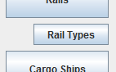

1. The Rail Types table will appear in the main area

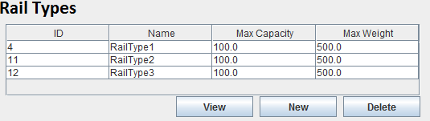

1. Select the Rail Type you wish to remove from the database



1. Click Delete



1. You will be prompted with a message box with the following warning, “Recovery of this object may not be possible after deletion, are you sure you wish to delete this Rail Type?”
2. Click Ok
3. The selected Rail Type will be marked as deleted in the database and will not be used in future routing.

**7. Routing A Shipment**

**7.1 Routing Algorithms**

The MMRP supplies various algorithms for solving the routing problem. Each algorithm is capable of finding solutions to the routing problem in thier own way. Each algorithm will explore different possibilities to get a shipment from the starting location to the end location. The way in which the different algorithms arrive at their different solutions will result in some good solutions and some bad solutions depending on the various components that the shipment being routed may have. That being said a variety of solutions used at the same time can generally find better solutions than any being used by itself.

**7.1.1 Node Crawler**

The Node Crawler algorithm is a random path choosing algorithm. This algorithm will, based on the variables passed into it, randomly attempt to get a direct path from the start to the end. If there are multiple direct paths to take, it will randomly choose one and return the route. If the algorithm chooses not to attempt a direct path it will grab all the paths that start at the shipments current location and randomly choose one to add to the total route. It will then check to see if it has randomly chosen a path that is connected to the end. If it has reached the destination the total route will return. If the end has not been reached the process will then repeat and it will choose if a direct path should be attempted.

**7.1.2 Best First Find**

The Best First Find algorithm is a deterministic algorithm, meaning given the same input it will give the same output every time. The Best First Find will attempt to find a direct path between the current location of the shipment and the destination. If it finds paths that allow direct travel it will choose the lowest cost path based on the given WeightedMetric. If no direct path is found, the algorithm will grab all the paths that start at the current location and choose the lowest cost path to traverse. Once at the new location it will attempt a direct path again. This process will repeat until it has found a direct path and reaches the destination. The total route will then be returned.

**7.1.3 Travel By Type**

The Travel By Type algorithm will route a shipment using only the vehicle mode chosen. This algorithm will randomly attempt a direct path using the given mode of travel. If a direct path is found it will choose the lowest cost path, based on the algorithm's WeightedMetric. If the direct path is not attempted, the algorithm will grab all the paths starting at the current location and then will either randomly choose the lowest cost path, or will choose a random path to add to the route. The algorithm will then check to see if it has reached the end. If the end has been reached the route will return. If the end has not been reached the process will repeat until the end is found.

**7.1.4 Next Available Vehicle**

The next available vehicle algorithm is an algorithm that attempts to reach its destination using the next vehicle that is ready to leave the current location. This algorithm will first attempt a direct path. If one is available it will choose the path with the next available vehicle for travelling and return the route. If a direct path is not available the algorithm will grab all the paths that start at the current location then choose the next available vehicle from all of them to traverse a path. It will then be checked to see if the end has been reached. If not the process will repeat and until the destination is reached.

**7.1.5 A Star**

Information to be added.

**7.2 Choosing An Algorithm**

Each algorithm offers a different search space that can be explored to reach the shipment's destination. Which algorithm to choose will depend on what the proirities of the shipment are. If fast results are needed Best First Find may be your best choice. If generally good results are required A star may be the best choice. If you want to explore the most possibilities then Node Crawler could be the best algorithm to select. Each choice can further be altered by selecting the metric priorities for the algorithm. These priorities will be used to determine the cost of using a given path.

**7.2.1 Selecting Weights**

There are currently 3 different metrics supported by the MMRP program. These metrics are Time, Distance, and Cost (financial). The Time metric for a Segment is how long it takes for the Vehicle travelling along the Segment to get from the starting Location of the Segment to the ending Location. The Distance metric is a measure of the distance a Vehicle has to travel to get from the starting Location to the ending Location of a Segment. The Cost is a measure of the finanical cost it will take to have the Vehicle transport the given Shipment along a Segment, based on that Segment's Shipping Rate. The weights for each of these metrics can be chosen on the Routing Menu using the spin fields next to the algorithms. Each spin bar is limited for a value between 0 and 100. The higher the number the more important that particular feature is to you. For example, if you were to set the Time spin bar to 100 and the Cost and Distance bars to 0 then only the time taken to traverse a Segment will be used to measure the best route. This may result in paths that take very little time, but have a high fiscal cost and distance values. It should be noted that the spin bar values act as a ratio. This fact means that setting each of the fields to the same value will result in each of the metrics an equal weight when the total cost is calculated.

**7.3 Route**

The route that is returned from the Route button will be the best path found from the selected algorithms with the user-defined values. The route itself will be an ordered list of Segments that the Shipment used to get from its current location to the end location. This list of Segments will be displayed in the table below the Route button in the order that they were traversed.

**7.3.1 Routing**

* + - * 1. Click on the Route button

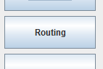

* + - * 1. A Shipment table with the Routing menu beneath it will appear

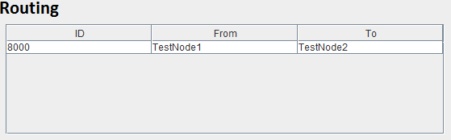

* + - * 1. Select the Shipment you wish to Route from the Shipment table



* + - * 1. Choose the algorithms you wish to use for routing

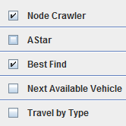

* + - * 1. Select the weights of the algorithms



* + - * 1. If applicable select the vehicle mode of travel



* + - * 1. Click Route



* + - * 1. After the routing is complete a table will appear beneath the routing menu containing all the segments in the order that they were traversed.

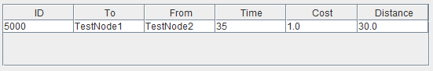

**8. Exploring Results**

**8.1 Interpreting Results**

The Segments that the Shipment took to get from its origin to its destination will be displayed in the Segment table below the Route button. The time, distance and cost of each of the Segments that had to be used will also be displayed.

**8.2 Saving Data**

Currently the MMRP program does not support saving the information out to any outisde files. The Shipment's Shipping History however will be updated in the database once the Shipment has been routed.

**9. Uninstalling MMRP**

Delete the MMRP application from the hard-drive. If you installed the database on your system it too will have to be deleted.